|  |  |
| --- | --- |
|  | **Incident Summary** |
| Blairlinnans WTW  Failure of Disinfection Process  28th September 2024  **Event Category: significant** | Event No. 14978 |

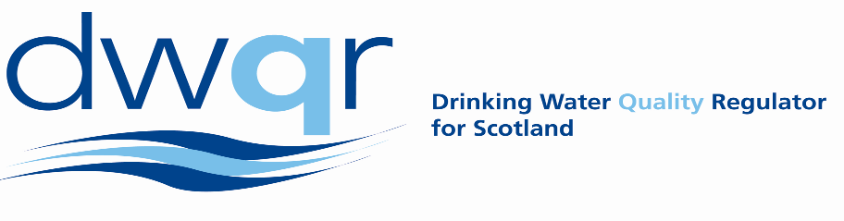

On the 28 September 2024 a significant volume of water entered supply that was not disinfected because a chlorine drum ran empty and failed to changeover to the standby drum. The low chlorine auto-shutdown had been left inhibited from planned works to the disinfection system that took place on the 24 September 2024. Treated water chlorine breached the Emergency Action Level (EAL) for approximately 1 hour 20 minutes. Whilst the final water chlorine remained above EAL (the lowest residual recorded as 0.7mg/l according to online monitors) this was due to blending of affected water within the clear water tanks (CWTs).

Scottish Water did not receive any water quality contacts associated with this incident. Sampling was arranged for the 28 – 29 September 2024, covering the WTW, and from the water supply zone. Of the 8 samples taken, none failed regulatory requirements.

The cause of this incident was due to failure of the site to shut down upon loss of chlorine dosing. This was due to inhibition of this facility four days earlier during planned work. The introduction of this inhibition was not in compliance with the approved methodology and was erroneously left in place following completion of the planned activity.

The event has been categorised as significant. Scottish Water has identified one action which DWQR accepts are appropriate and will monitor to ensure they are completed prior to signing off the incident. DWQR made zero additional recommendations.