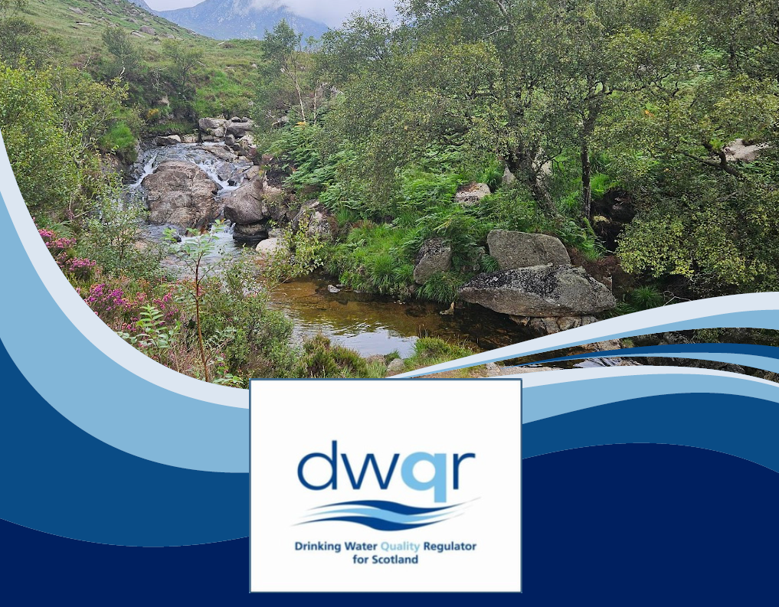

Drinking Water Quality in Scotland 2024
DWQR Annual Report Private Water Supplies

SAFEGUARDING YOUR DRINKING WATER
DRINKING WATER QUALITY REGULATOR FOR SCOTLAND

TABLE OF CONTENTS

1. TYPES OF PRIVATE WATER SUPPLIES IN SCOTLAND 54
2. TESTING OF REGULATED PRIVATE WATER SUPPLIES 109
2.1 Regulated Supplies 109
2.1.1 Compliance 1312
2.1.2 Investigation and Enforcement 1413
2.2 Type B Supplies 1615
3. RISK ASSESSMENT 2019
4. OTHER DWQR ACTIVITY 2524
4.1 Contacts to DWQR 2524
4.2 Policy Development 2524
4.3 Information for Owners and Users of PWS 2524
4.4 Supervision & Training 2624
5. ANNEXES 2625
5.1 Regulatory Framework 2625
5.2 Acknowledgement 2827
6. PERFORMANCE BY EACH LOCAL AUTHORITY FOR 2024 2928



2,347 (44%) Risk Assessments completed in 2024
in 2024
1,827 (35%)
Risk Assessments
completed in 2023
2024 IN REVIEW: PRIVATE SUPPLIES IN SCOTLAND

65% of
Regulated Supplies
sampled in 2023

69% of
Regulated Supplies
sampled in 2024

Private Water Supplies (PWS) are drinking
water supplies which are not provided by
Scottish Water.

Regulated Supplies are those which supply
more than 50 people, provide 10 cubic
meters or more of water per day or are
supplying premises that are commercial
or performing a public activity.

Type B Supplies are other smaller, domestic
supplies


Total of 13
Enforcement
Notices served
in 2023
Total of 4
Enforcement Notices served
in 2024


2,055
Investigations
undertaken in
2023
2,131
Investigations undertaken in
2024


92.7%
23,158 Private Water Supplies in Scotland

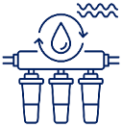
17,800 Type B Supplies serving around 126,231 people


5,299 Regulated Supplies serving around 66,873 people
Images supplied using the following links: Borehole Water filter River Risk assessment Test Tube Enforcement Inspector Well

TYPES OF PRIVATE WATER SUPPLIES IN SCOTLAND

Private Water Supplies (PWS) are drinking water supplies which are not provided by Scottish Water. Responsibility for these supplies lies with their owners and users. PWS are regulated by local authorities, which in turn are supervised by the Drinking Water Quality Regulator (DWQR).

Local authorities are required to submit annual data to the DWQR, which is used to compile this Annual Report. The regulation of PWS is governed by specific legislation and guidance, including:

- The Water Intended for Human Consumption (Private Supplies) (Scotland) Regulations 2017
- The Private Water Supplies (Scotland) Regulations 2006

Local authorities work closely with the DWQR to improve the quality and safety of PWS across Scotland. They also liaise with the Society of Chief Officers of Environmental Health in Scotland to support this work.

The data submitted by local authorities for 2024 indicate that there are 23,158 private supplies in Scotland, an increase of 124 from 23,034 supplies reported for 2023. These data show that around 2.5% of the Scottish population rely on a private water supply. However, this figure is likely to underestimate the true number of individuals served, as it does not account for the large number of visitors to commercial premises including tourists, employees, and consumers of products from food premises.
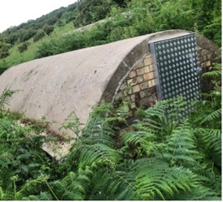
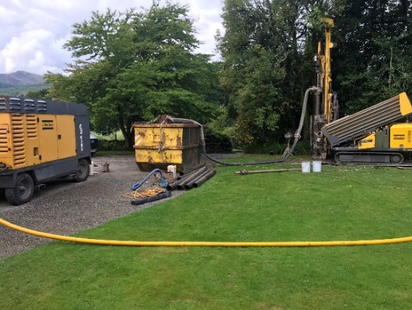
Figure 11 Drilling a new borehole.

Figure 22 A collection chamber in South Ayrshire.

Private Water Supplies in Scotland are classified into two categories:

- Regulated Supplies (formerly known as Type A): These are regulated under the 2017 Regulations, and include supplies that serve 50 or more people, provide 10 cubic metres or more of water per day, or supply premises involved in commercial or public activities. Examples include holiday lets, B&Bs, hotels, caravan parks, schools, community halls, and food businesses.

- Type B Supplies: These are regulated under the 2006 Regulations, and are smaller, typically domestic supplies, many of which serve single properties.

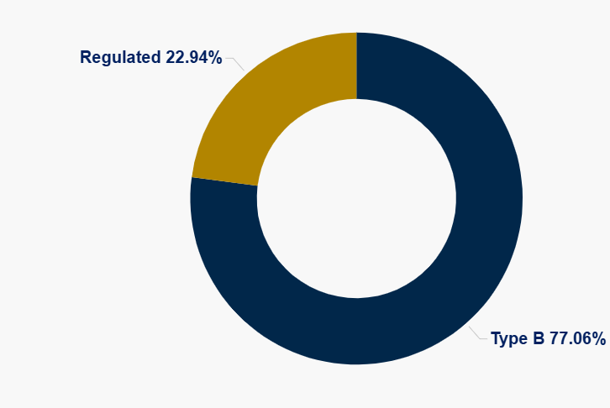

Figure 3 Relative proportions of the two different categories of supply reported to DWQR for 2024.

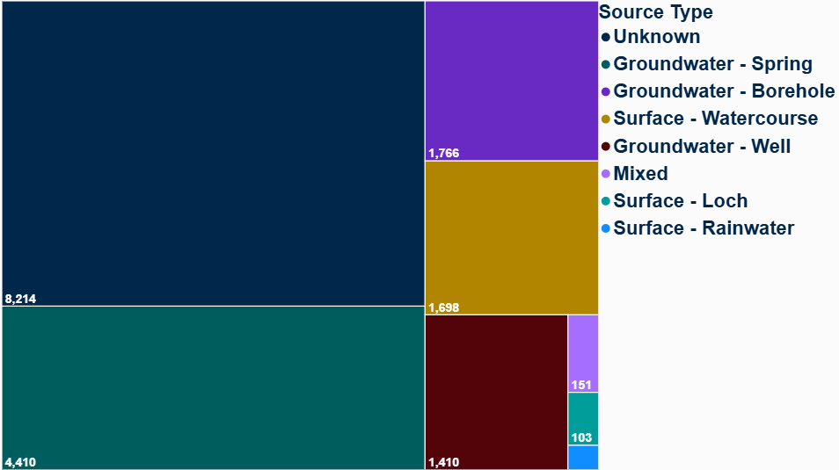
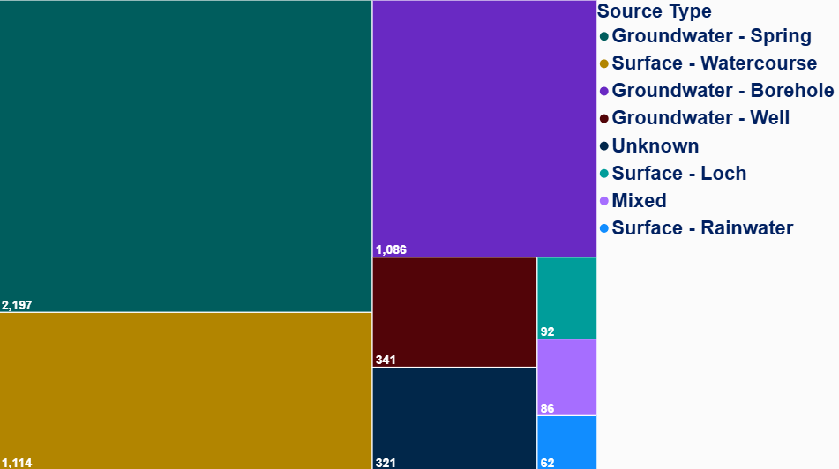
48
Figure 4 Number of regulated private water supplies with each source type.

Figure 5 Number of type B private water supplies with each source type.

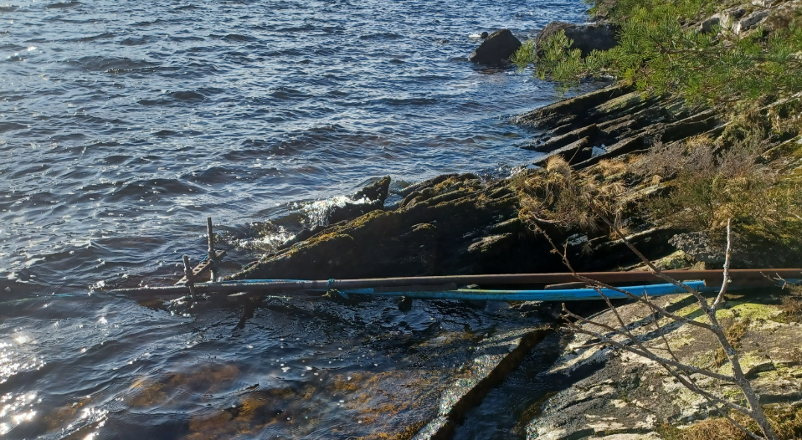
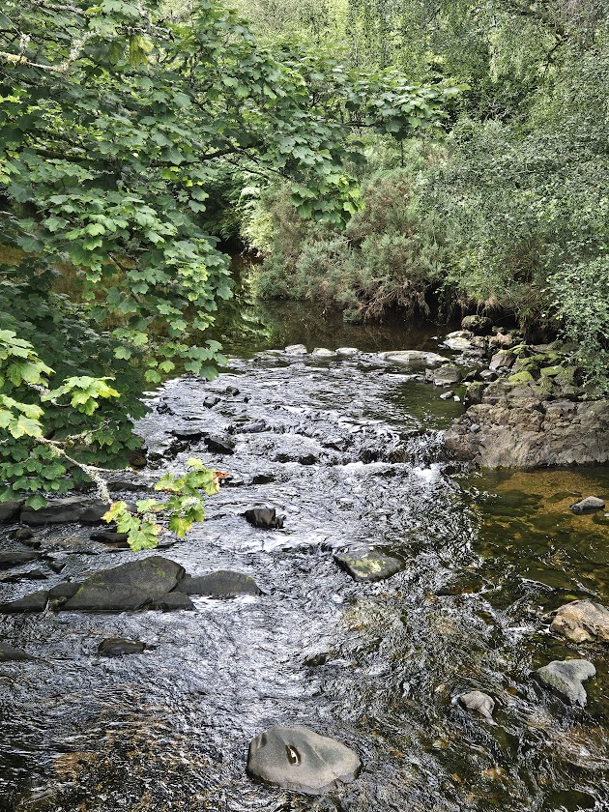

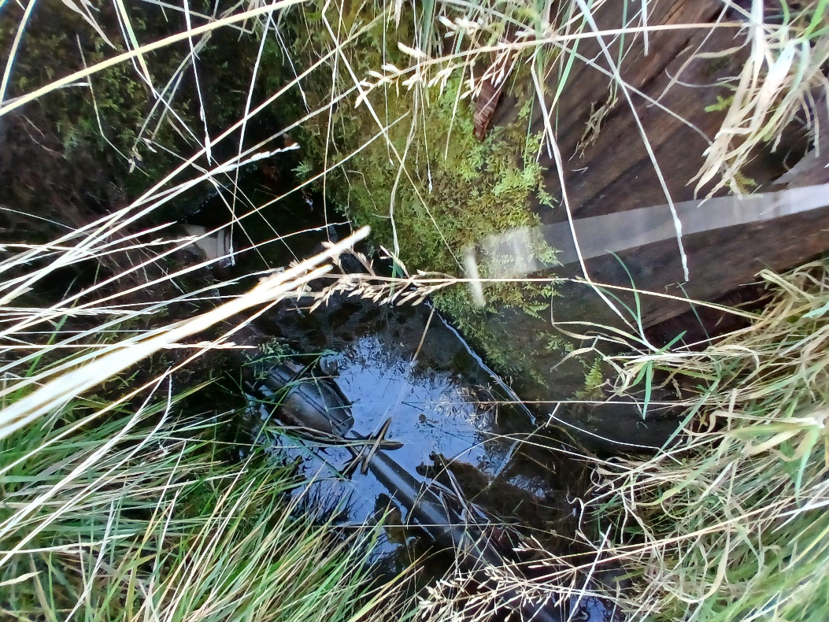

Figures 6-8 Examples of surface water sources used for private water supplies.

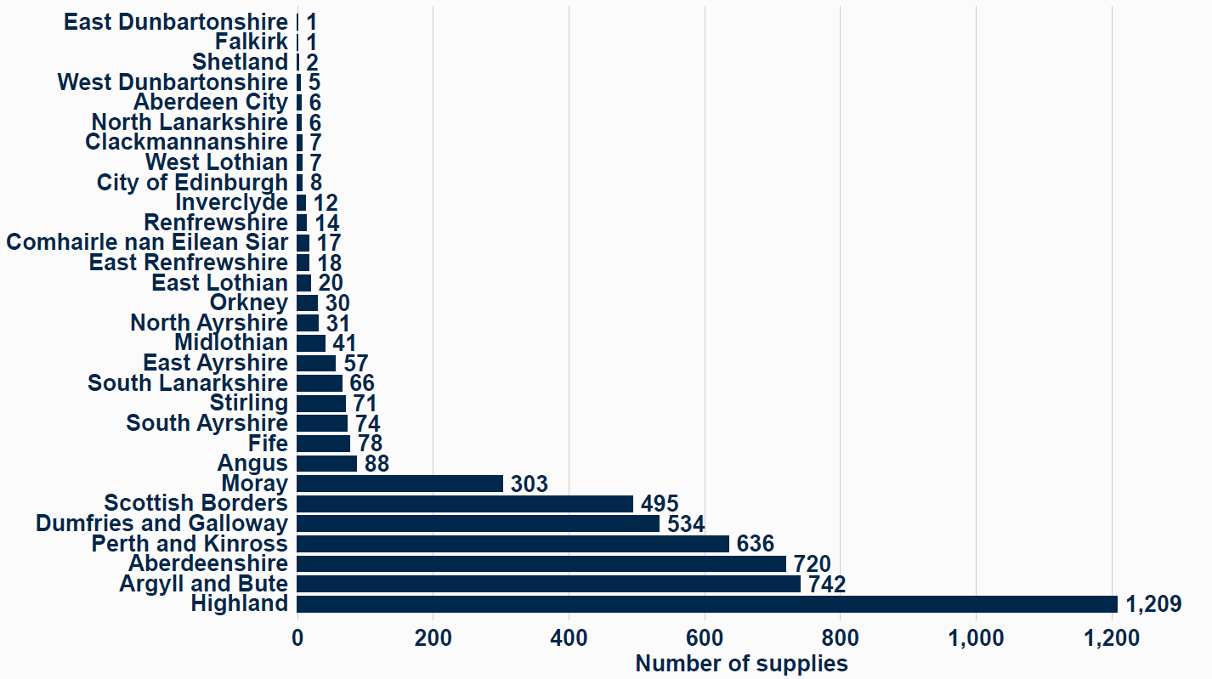
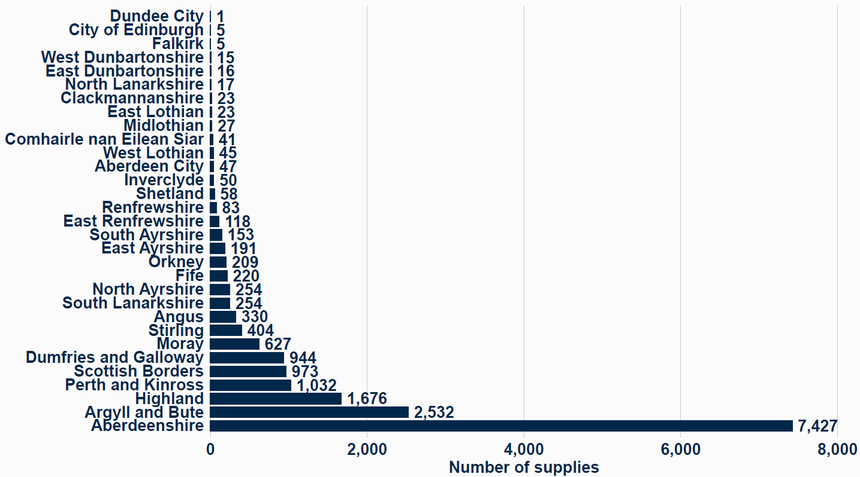
Figure 9 Number of regulated private water supplies in each local authority area.

Figure 10 Number of type B private water supplies in each local authority area.

2. TESTING OF REGULATED PRIVATE WATER SUPPLIES

2.1 Regulated Supplies

All Regulated supplies are required to be sampled and tested annually.
Table 1 shows the number of supplies that have been sampled in each local authority area, compared with the total number of supplies present. It also shows the population in each local authority area that are supplied by these PWS.

Table 11 Regulated private water supplies by local authority area.
Local Authority | Number of supplies | Population served | Number of supplies sampled | % of supplies sampled
Aberdeen City | 6 | 199 | 6 | 100%
Aberdeenshire | 720 | 6,635 | 495 | 69%
Angus | 88 | 1,513 | 68 | 77%
Argyll and Bute | 742 | 17,630 | 491 | 66%
City of Edinburgh | 8 | 187 | 7 | 88%
Clackmannanshire | 7 | 171 | 6 | 86%
Comhairle nan Eilean Siar | 17 | 345 | 14 | 82%
Dumfries and Galloway | 534 | 15,507 | 363 | 68%
Dundee City | 0 | 0 | 0 | No Supplies
East Ayrshire | 57 | 265 | 47 | 82%
East Dunbartonshire | 1 | 40 | 1 | 100%
East Lothian | 20 | 441 | 19 | 95%
East Renfrewshire | 18 | 637 | 17 | 94%
Falkirk | 1 | 0 | 1 | 100%
Fife | 78 | 2,995 | 78 | 100%
Glasgow City | 0 | 0 | 0 | No Supplies
Highland | 1,209 | 34,082 | 796 | 66%
Inverclyde | 12 | 830 | 12 | 100%
Midlothian | 41 | 534 | 41 | 100%
Moray | 303 | 3,050 | 267 | 88%
North Ayrshire | 31 | 356 | 29 | 94%
North Lanarkshire | 6 | 11 | 6 | 100%
Orkney | 30 | 801 | 29 | 97%
Perth and Kinross | 636 | 23,454 | 291 | 46%
Renfrewshire | 14 | 429 | 13 | 93%
Scottish Borders | 495 | 10,555 | 418 | 84%
Shetland | 2 | 8 | 1 | 50%
South Ayrshire | 74 | 1,009 | 65 | 88%
South Lanarkshire | 66 | 652 | 35 | 53%
Stirling | 71 | 3,463 | 44 | 62%
West Dunbartonshire | 5 | 111 | 5 | 100%
West Lothian | 7 | 323 | 7 | 100%
Total | 5,299 | 126,231 | 3,672 | 69%

Recent legislation to licence short term let properties in Scotland has led to an increase in Regulated supplies across the country, and local authorities are prioritising the administration of these additional supplies based on public health need. The increase in PWS reported in 2024 is partly due to the registration of these properties. The changing numbers make year-on-year comparisons difficult. Compliance with the statutory requirement to sample all regulated water supplies annually has improved across Scotland, rising from 65% in 2023 to 69% in 2024.
Significant performance improvements were observed in several local authority areas:

- East Ayrshire: increased markedly from 10% in 2023 to 82% in 2024
- Stirling: improved from 16% in 2023 to 62% in 2024
- Angus: rose from 55% in 2023 to 77% in 2024

These gains are largely attributed to enhanced resource allocation, with some authorities recruiting additional staff to conduct sampling and inspections, while others opted to outsource these activities to external providers. A modest improvement was also noted in Argyll and Bute Council, where compliance rose from 59% in 2023 to 66% in 2024.

Compliance with the annual sampling requirement for Regulated supplies within Perth and Kinross Council has continued to decline, falling from 72% in 2022 to 55% in 2023, and further to 46% in 2024. This downward trend is primarily attributed to the loss of experienced personnel and ongoing challenges in recruiting suitably qualified staff to carry out sampling and inspection duties.

Most local authorities maintained performance levels consistent with previous years. Notably, the following councils achieved 100% compliance with the annual sampling requirement for regulated supplies:

- Aberdeen City
- East Dunbartonshire
- Falkirk
- Fife
- Inverclyde
- Midlothian
- North Lanarkshire
- West Dunbartonshire
- West Lothian

Several of these areas manage a relatively small number of supplies, which can contribute to higher compliance rates. In contrast, local authorities responsible for a larger volume of supplies, particularly those located in remote or geographically challenging areas, face additional operational complexities that can impact performance.

2.1.1 Compliance

All Regulated water supplies are required to be tested annually for a defined set of chemical and microbiological parameters, which are critical to safeguarding public health and maintaining consumer confidence. Samples are collected directly from taps used for drinking water, ensuring they accurately reflect the quality of water consumed by users.

In 2024, as in previous years, the parameter with the highest rate of non-compliance was coliform bacteria, with 20.5% of samples failing this test. This represents a slight improvement from the 2023 failure rate of 21.2%. Coliform bacteria are naturally present in soil and the wider environment; their detection in drinking water indicates inadequate or ineffective treatment of private water supplies. E. coli was found in 10.1% of samples, which is concerning as this indicates that faecal contamination may be present.

These findings underscore the importance of continued risk assessment and routine testing by local authorities. They also highlight the need for supply owners and users to ensure that treatment systems are properly maintained and functioning effectively.

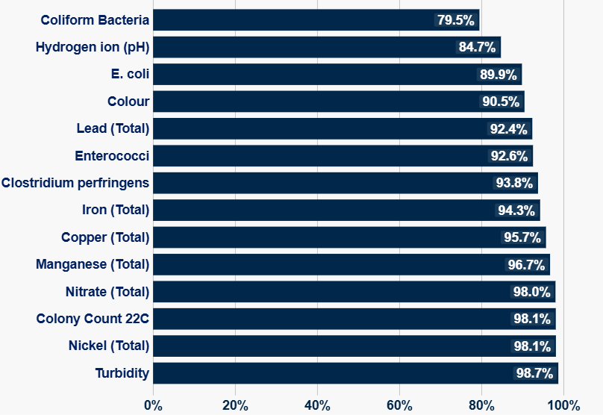

Parameter

% Compliance

Figure 11 Key parameter compliance for regulated private water supplies.

2.1.2 Investigation and Enforcement

Local authorities are responsible for investigating failures in PWS to identify the underlying causes and to encourage owners to undertake necessary improvements. These improvements may involve actions at the water source, such as fencing off an intake, drilling a new borehole, or upgrading treatment systems to remove contaminants.

To support these efforts, PWS owners and users may apply for financial assistance through the Scottish Government grant scheme, administered by their local authority.

Where informal engagement proves unsuccessful and supply owners are unwilling to make required improvements, local authorities may initiate enforcement action. The 2017 Regulations provide a range of Enforcement Notices to support this process. These include powers to require the provision of information, as well as emergency notices to restrict or prohibit the use of a water supply where there is a risk to public health.

Table 22 Number of investigations and enforcement by local authority for regulated supplies.
Local Authority | Number Investigations | Number Enforcement Notices
Scottish Borders | 273 | 2
Midlothian | 34 | 1
South Lanarkshire | 62 | 0
Aberdeen City | 1 | 0
Aberdeenshire | 814 | 0
Argyll and Bute | 288 | 0
East Renfrewshire | 1 | 0
Fife | 22 | 0
Highland | 155 | 0
North Ayrshire | 7 | 0
Orkney | 11 | 0
Total | 1,668 | 3
Note: Local authorities not listed above recorded no investigations or enforcement notices.
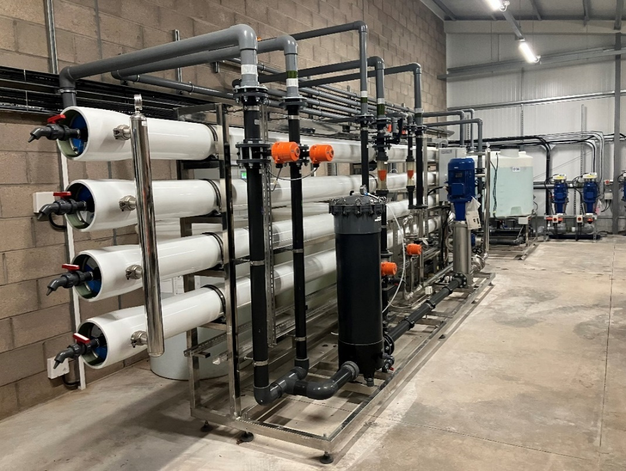

Figure 12 A membrane filtration system at a large regulated private water supply.

2.2 Type B Supplies

Type B PWS are only tested when requested by the owners or users. As a result, many of these supplies remain untested, contributing to the relatively low volume of monitoring data available across Scotland.

Testing is most commonly requested when owners are seeking to upgrade their supply, as a water quality test result is typically required as part of the grant application process to demonstrate improvement. Additionally, water quality testing is often carried out during property sales to confirm that the supply is wholesome.

Given the limited involvement of local authorities with Type B supplies, it is essential that owners and users take an active role in the ongoing treatment and maintenance of their water supply to ensure its safety and reliability.

Table 33 Type B private water supplies by local authority area.
Local Authority | Number of supplies | Population served | Number of supplies sampled | % of supplies sampled
Aberdeen City | 47 | 193 | 1 | 2%
Aberdeenshire | 7,427 | 21,573 | 225 | 3%
Angus | 330 | 255 | 10 | 3%
Argyll and Bute | 2,532 | 9,303 | 69 | 3%
City of Edinburgh | 5 | 25 | 0 | 0%
Clackmannanshire | 23 | 156 | 2 | 9%
Comhairle nan Eilean Siar | 41 | 86 | 1 | 2%
Dumfries and Galloway | 944 | 2,592 | 59 | 6%
Dundee City | 1 | 24 | 0 | 0%
East Ayrshire | 191 | 747 | 35 | 18%
East Dunbartonshire | 16 | 102 | 0 | 0%
East Lothian | 23 | 185 | 1 | 4%
East Renfrewshire | 118 | 344 | 5 | 4%
Falkirk | 5 | 29 | 0 | 0%
Fife | 220 | 1,178 | 12 | 5%
Glasgow City | 0 | 0 | 0 | No Supplies
Highland | 1,676 | 8,787 | 76 | 5%
Inverclyde | 50 | 273 | 3 | 6%
Midlothian | 27 | 86 | 3 | 11%
Moray | 627 | 2,028 | 38 | 6%
North Ayrshire | 254 | 1,347 | 14 | 6%
North Lanarkshire | 17 | 47 | 0 | 0%
Orkney | 209 | 530 | 12 | 6%
Perth and Kinross | 1,032 | 7,862 | 60 | 6%
Renfrewshire | 83 | 220 | 7 | 8%
Scottish Borders | 973 | 4,984 | 56 | 6%
Shetland | 58 | 152 | 1 | 2%
South Ayrshire | 153 | 443 | 16 | 10%
South Lanarkshire | 66 | 652 | 35 | 53%
Stirling | 404 | 2,032 | 24 | 6%
West Dunbartonshire | 15 | 65 | 0 | 0%
West Lothian | 45 | 196 | 5 | 11%
Total | 17,800 | 66,873 | 745 | 4%

2.2.1 Compliance

In 2024, coliform bacteria continued to be the parameter with the highest rate of non-compliance, with 34.6% of all samples failing, closely mirroring the 2023 figure. E. coli was found in 15.9% of samples. This highlights the presence of faecal contamination as well as the absence of effective disinfection processes in many PWS.

Additionally, the data suggests that some supply owners and users may lack the necessary knowledge or expertise to properly operate and maintain their treatment systems. This reinforces the need for ongoing education, support, and oversight to ensure water safety and protect public health.
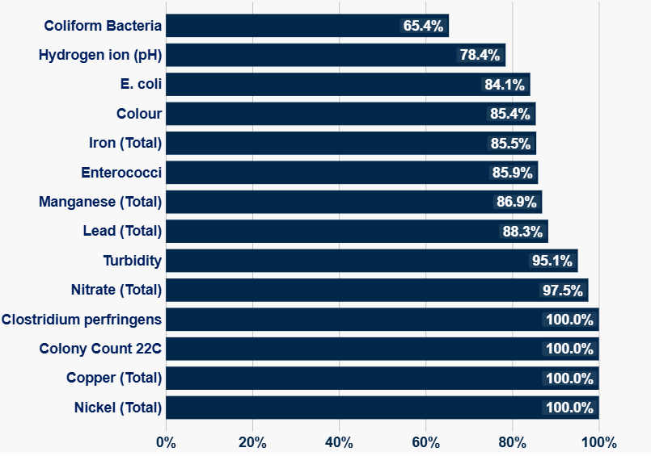
Figure 13 Key parameter compliance for type B private water supplies.

% Compliance

Parameter

2.2.2 Investigation and Enforcement

Local authorities investigate Type B PWS when owners or users express concerns about water quality or quantity, particularly when they are seeking to improve their supply. These improvements are often supported through available PWS grant funding.

Where informal engagement is insufficient to gather necessary information or to prompt action, enforcement measures may be taken. This is especially important in cases where a supply is known to pose an imminent risk to public health. In such instances, local authorities are empowered to require upgrades to ensure the safety of the water supply.

Table 4 Number of investigations and enforcement by local authority for type B private water supplies.

Local Authority | Number Investigations | Number Enforcement Notices
South Lanarkshire | 90 | 1
Aberdeen City | 1 | 0
Aberdeenshire | 274 | 0
Argyll and Bute | 38 | 0
East Lothian | 1 | 0
Fife | 1 | 0
Highland | 4 | 0
Orkney | 7 | 0
Scottish Borders | 47 | 0
Total | 463 | 1
Note: Local authorities not listed above recorded no investigations or enforcement notices.

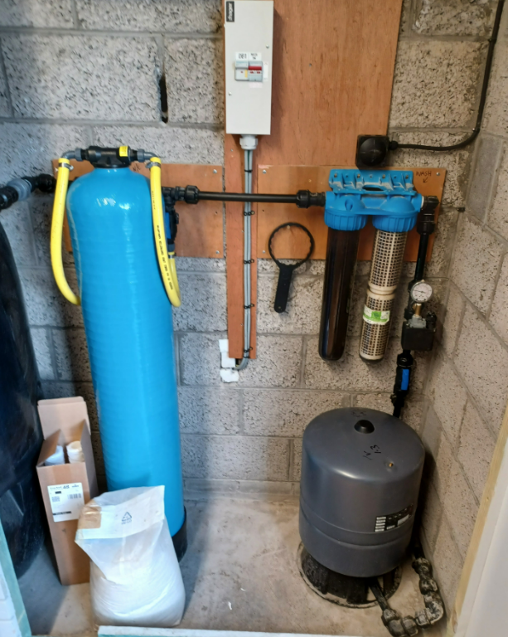
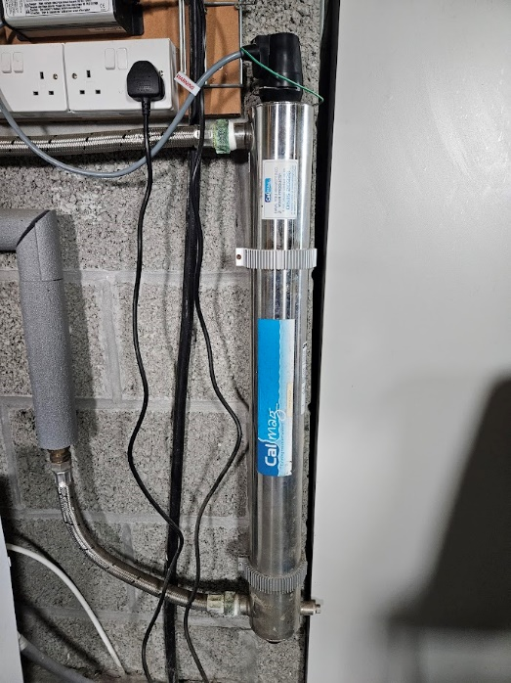
Figure 15 An example of a filter system.
Figure 14 A example of UV system.

RISK ASSESSMENT

Risk assessment plays a critical role in safeguarding the quality and safety of PWS. Unlike sampling, which provides a snapshot of water quality at a specific time and location, risk assessments offer a comprehensive evaluation of all potential hazards that could affect a supply under varying conditions. This process also considers any existing mitigation measures and ensures they are properly documented.

Under the 2017 Regulations, local authorities are legally required to carry out risk assessments for all Regulated supplies at least once every five years, using an online tool created and managed by the DWQR. In addition, they must provide advice and assistance on risk assessments to those responsible for Type B supplies upon request.
The 2017 Regulations required all initial risk assessments to be completed by 1 January 2022. Table 4 shows progress made by individual local authorities up to July 2025. The number of supplies risk assessed has increased from 35% in 2024 to 44% in 2025.
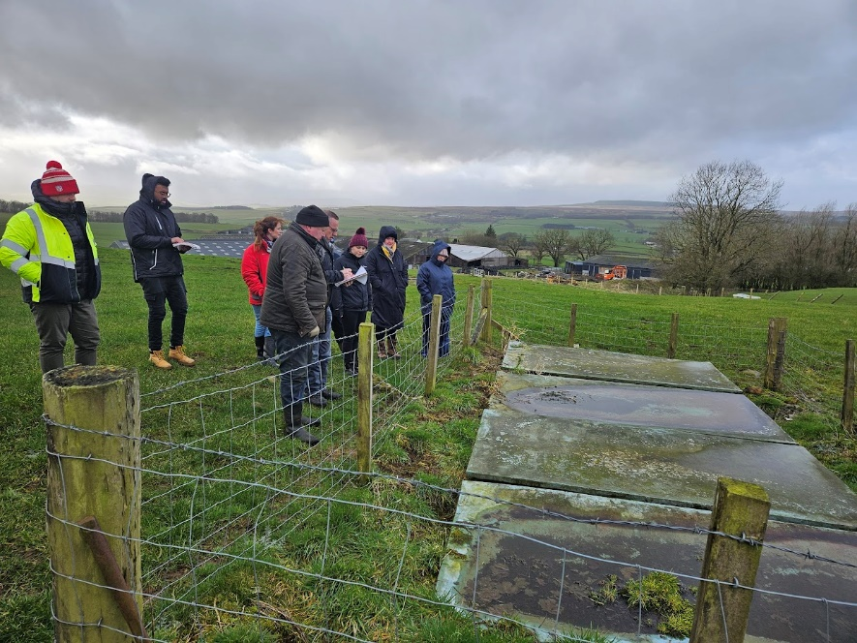
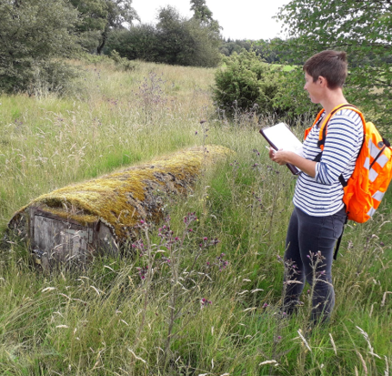
Figure 17 A group of students carrying out a risk assessment along with a local authority officer and DWQR staff.
Figure 16 A local authority officer carrying out a risk assessment.

Figure 18

Figure 18 Progress on regulated private water supply risk assessments by July 2025.

Figure 19 Number of local authorities grouped by % risk assessment completion for regulated private water supplies.

Table 44 Risk assessment of regulated supplies by local authority
Local Authority Name | Regulated Supplies | Regulated RAs Complete Jul 2025 | Regulated RAs Complete % Jul 2025 | Regulated RAs Partially Complete Jul 2025 | Regulated RAs Completed During Year to Jul 2025
Aberdeen City Council | 6 | 5 | 83% | 0 | 0
Aberdeenshire Council | 720 | 366 | 51% | 69 | 62
Angus Council | 88 | 23 | 26% | 25 | 7
Argyll and Bute Council | 742 | 185 | 25% | 31 | 56
City of Edinburgh Council | 8 | 8 | 100% | 0 | 4
Clackmannanshire Council | 7 | 6 | 86% | 0 | 4
Comhairle nan Eilean Siar | 17 | 8 | 47% | 6 | 0
Dumfries and Galloway Council | 534 | 240 | 45% | 7 | 28
Dundee City Council | 0 | 0 | N/A | N/A | N/A
East Ayrshire Council | 57 | 32 | 56% | 10 | 22
East Dunbartonshire Council | 1 | 1 | 100% | 0 | 0
East Lothian Council | 20 | 20 | 100% | 4 | 0
East Renfrewshire Council | 18 | 3 | 17% | 7 | 0
Falkirk Council | 1 | 1 | 100% | 0 | 0
Fife Council | 78 | 78 | 100% | 0 | 8
Glasgow City Council | 0 | 0 | N/A | N/A | N/A
Highland Council | 1209 | 556 | 46% | 24 | 181
Inverclyde Council | 12 | 12 | 100% | 0 | 2
Midlothian Council | 41 | 29 | 71% | 8 | 19
Moray Council | 303 | 278 | 92% | 2 | 61
North Ayrshire Council | 31 | 12 | 39% | 0 | 3
North Lanarkshire Council | 6 | 4 | 67% | 0 | 0
Orkney Islands Council | 30 | 21 | 70% | 4 | 0
Perth and Kinross Council | 636 | 133 | 21% | 6 | 0
Renfrewshire Council | 14 | 10 | 71% | 1 | 2
Scottish Borders Council | 495 | 172 | 35% | 3 | 27
Shetland Islands Council | 2 | 0 | 0% | 2 | 0
South Ayrshire Council | 74 | 72 | 97% | 1 | 11
South Lanarkshire Council | 66 | 44 | 67% | 8 | 7
Stirling Council | 71 | 18 | 25% | 2 | 15
West Dunbartonshire Council | 5 | 4 | 80% | 2 | 0
West Lothian Council | 7 | 6 | 86% | 6 | 1
Total: | 5299 | 2,347 | 44% | 228 | 519

Figure 20 Top Ten Risk Categories Taken from DWQR’s Risk Assessment Tool
(The bars on the chart show the mean risk scores before and after mitigations have been put in place.)

The risk assessment comprises a structured set of questions addressing key elements of the water supply chain, from source to tap. Each item is evaluated by the risk assessor using a scoring system. A severity score, rated on a scale of 1 to 5, is assigned and multiplied by a likelihood score also rated from 1 to 5 to determine the initial risk rating.
Following the implementation of mitigation measures, a secondary assessment is conducted. Revised scores for severity and likelihood are applied to reflect any reduced risk, providing a comparative view of the effectiveness of any interventions.
Figure 20 presents the ten highest average risk scores across all PWS, both before and after the mitigating measures have been added, such as treatment or source protection. This shows the most significant risks currently affecting PWS.
The top three risk categories based on both unmitigated and mitigated scores were:

- System – Inadequate Management
- Source – Faecal Contamination in Catchment
- Tank – Source of Microbial Contamination

While the categories with the highest scores remain broadly consistent with the previous year, ‘System – Inadequate Management’ has now overtaken ‘Source – Faecal Contamination’ as the most prominent risk factor. This shift underscores the critical importance of effective management and maintenance in safeguarding water quality.
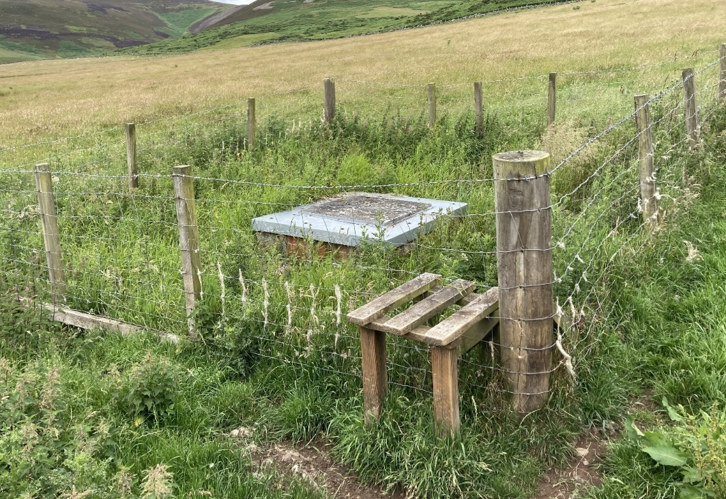

Figure 21 An example of mitigation (fencing) to protect a water storage tank at a private water supply.

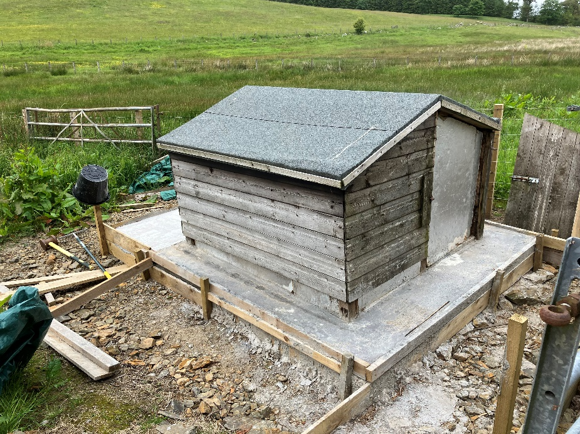
Figure 22 An example of mitigation (housing) to protect a private water supply source.

Figure 22 An example of mitigation (housing) to protect a private water supply source.

OTHER DWQR ACTIVITY

4.1 Contacts to DWQR

In 2024, the DWQR received a total of fifty contacts relating to PWS. Of these, nineteen enquiries came from PWS owners and users. Common themes included concerns about water quality, guidance on water testing, and questions regarding the relevant legislation.

A further twenty-six complex enquiries were submitted by local authorities. These covered a range of topics, including technical queries on conducting risk assessments, use of the DWQR risk assessment tool, and emerging disinfection technologies. Local authorities also sought clarification on the application of PWS regulations. There were also a further two from MSPs and one from an NHS Health Board, all regarding data and how it is recorded.

4.2 Policy Development

DWQR actively supports policy development initiatives led by the Scottish Government by offering expert technical guidance and contributing to the formulation of future policy. This ongoing collaboration underscores DWQR’s broader commitment to maintaining a robust regulatory framework that safeguards public health and enhances the resilience of water supply systems.

4.3 Information for Owners and Users of PWS

DWQR continues to enhance the availability of information for owners and users of PWS, supporting them in maintaining the safety and quality of their water. Comprehensive guidance can be found on the Scottish Government website at Owning or using a private water supply - mygov.scot. Additionally, a straightforward risk assessment tool is available to help users identify and mitigate potential risks: Find ways to make your private water supply safer - mygov.scot

4.4 Supervision & Training

DWQR has a statutory duty to supervise local authorities in their regulation of PWS. As part of this role, we have conducted supervisory visits to a number of local authorities to review progress in sampling and risk assessment activities, and to investigate the causes of any shortfalls. In several instances, DWQR has collaborated with local authorities to develop and implement action plans aimed at supporting future improvements.

A recurring challenge reported by local authorities is insufficient staffing, with recruitment proving particularly difficult. Additionally, accessing remote locations continues to present logistical difficulties. DWQR remains committed to providing ongoing support and guidance to local authorities in fulfilling their public health responsibilities, while also holding them accountable where underperformance is identified.

In 2024, DWQR drinking water specialists carried out multiple site visits to assist local authorities with risk assessments and to deliver expert advice and training to environmental health officers and students.

In September 2024, DWQR hosted a Training and Update Day for PWS professionals from local authorities across Scotland. This hybrid event, held at Victoria Quay in Edinburgh and online, covered legislative updates, data provision, and the operational challenges of managing remote supplies. The event was well attended, and DWQR plans to make it an annual fixture.

DWQR has also delivered targeted training on the use of the PWS risk assessment portal and the annual data return process. Recordings of these sessions are available to local authority colleagues upon request.

5. ANNEXES

5.1 Regulatory Framework

The regulatory framework for drinking water quality in Scotland is rooted in European Union Directives. A recast Drinking Water Directive was adopted by the EU in December 2020, introducing updated standards aimed at further safeguarding public health. Although the UK has left the EU, Scotland has chosen to maintain alignment with these high standards which will be introduced over the coming years.

The standards set out in the Directive are informed by guidelines developed by the World Health Organisation (WHO), ensuring a science-based approach to protecting public health. Water quality legislation relating to PWS includes:

Water (Scotland) Act 1980 (as amended)

This Act requires local authorities to secure improvements to PWS if they consider them necessary. Water (Scotland) Act 1980

Water Industry (Scotland) Act 2002

This Act created the role of the DWQR, an independent authority not subject to direction by the Scottish Ministers. In relation to PWS, the DWQR is required to supervise the enforcement by local authorities of their drinking water quality obligations. Local authorities are required to provide the DWQR with any information necessary to undertake that supervisory role. The DWQR is required to submit and publish an annual report to Scottish Ministers detailing his activities. Water Industry (Scotland) Act 2002

The Private Water Supplies (Scotland) Regulations 2006

These regulations define the wholesomeness of drinking water with reference to the European Drinking Water Directive 98/83/EC, which came into force in 1998. The standards set out in the Directive are based on recommendations from the WHO regarding the protection of human health through safe drinking water. Although the regulations have been significantly amended over time, they continue to include provisions specific to Type B supplies, particularly in relation to monitoring requirements and the provision of public health advice. The Private Water Supplies (Scotland) Regulations 2006

The Private Water Supplies (Grants) (Scotland) Regulations 2006

Under these regulations, local authorities are empowered to provide a non-means-tested grant of up to £800 to eligible individuals. This grant is available to support improvements to

PWS, including both Regulated supplies and Type B supplies.
The Private Water Supplies (Grants) (Scotland) Regulations 2006
Apply for a private water supply grant - mygov.scot

The Water Intended for Human Consumption (Private Supplies) (Scotland) Regulations 2017

These regulations came into force on 27 October 2017, replacing and partially re-enacting, with modifications, the provisions of The Private Water Supplies (Scotland) Regulations 2006 in relation to Regulated supplies (formerly referred to as “Type A” supplies).

The Water Intended for Human Consumption (Private Supplies) (Scotland) Regulations 2017

Guidance issued by DWQR clarifies that domestic rented properties fall within the scope of commercial activity for the purposes of these regulations.

Guidance on the Water Intended for Human Consumption (Private Supplies) (Scotland) Regulations 2017

5.2 Acknowledgement
A special thanks to the local authorities that have supplied the photographs for this report.

6. PERFORMANCE BY EACH LOCAL AUTHORITY FOR 2024

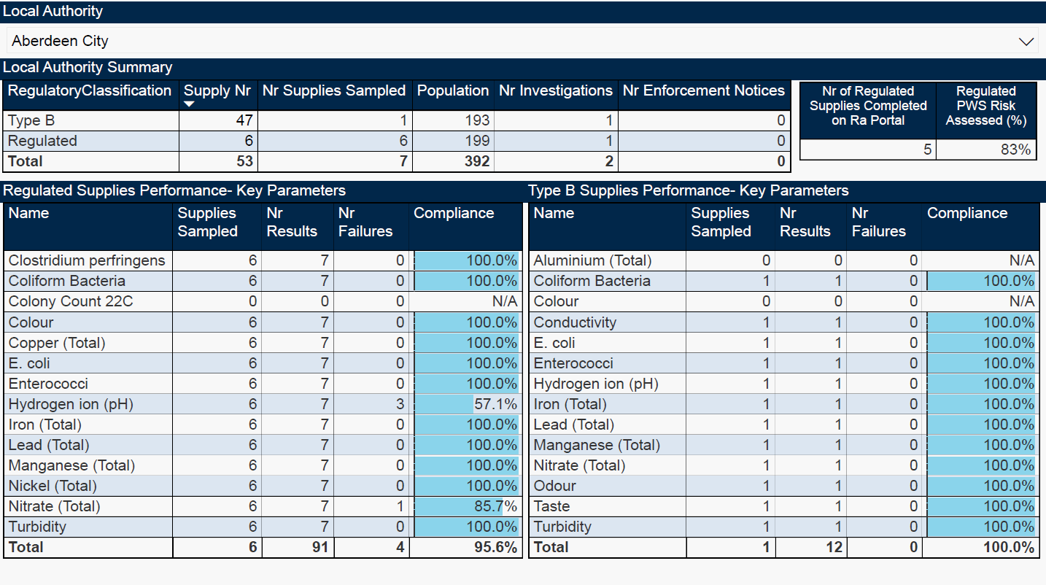

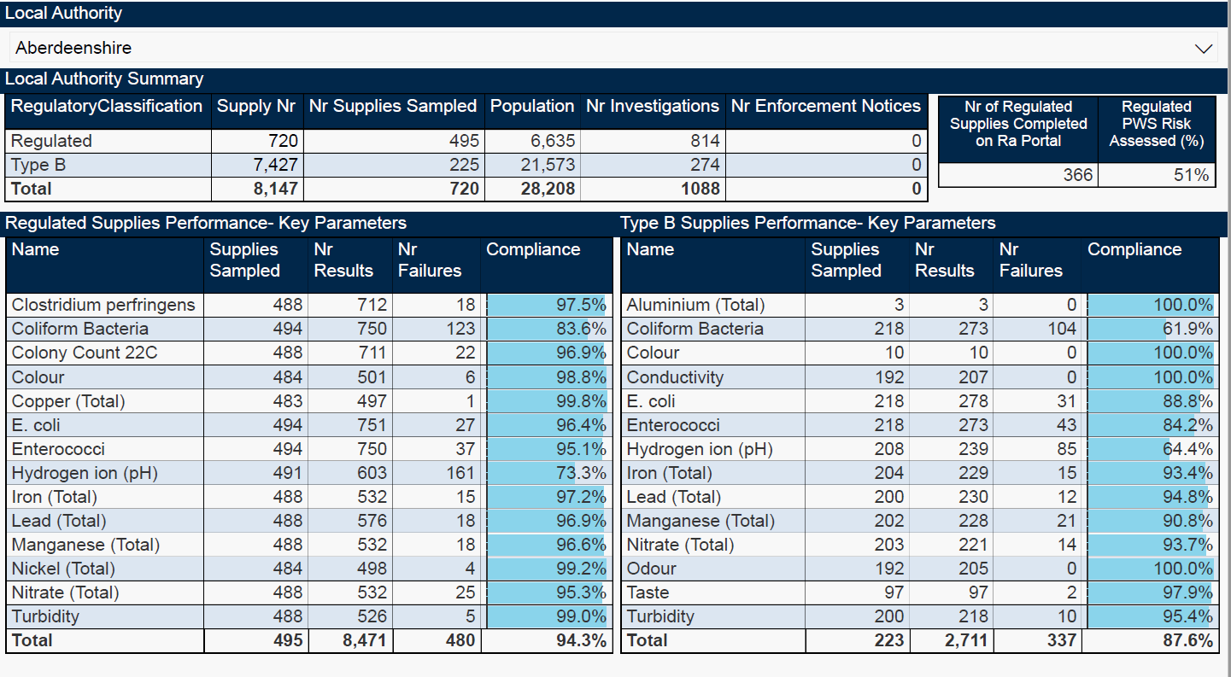

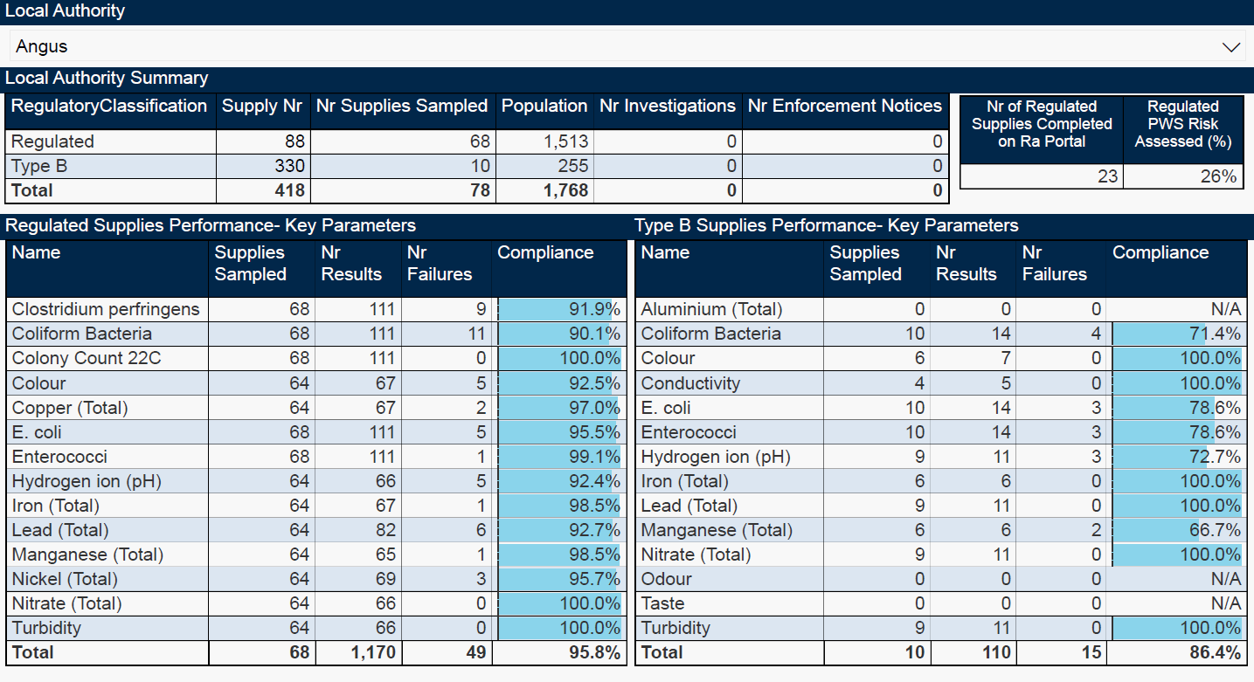

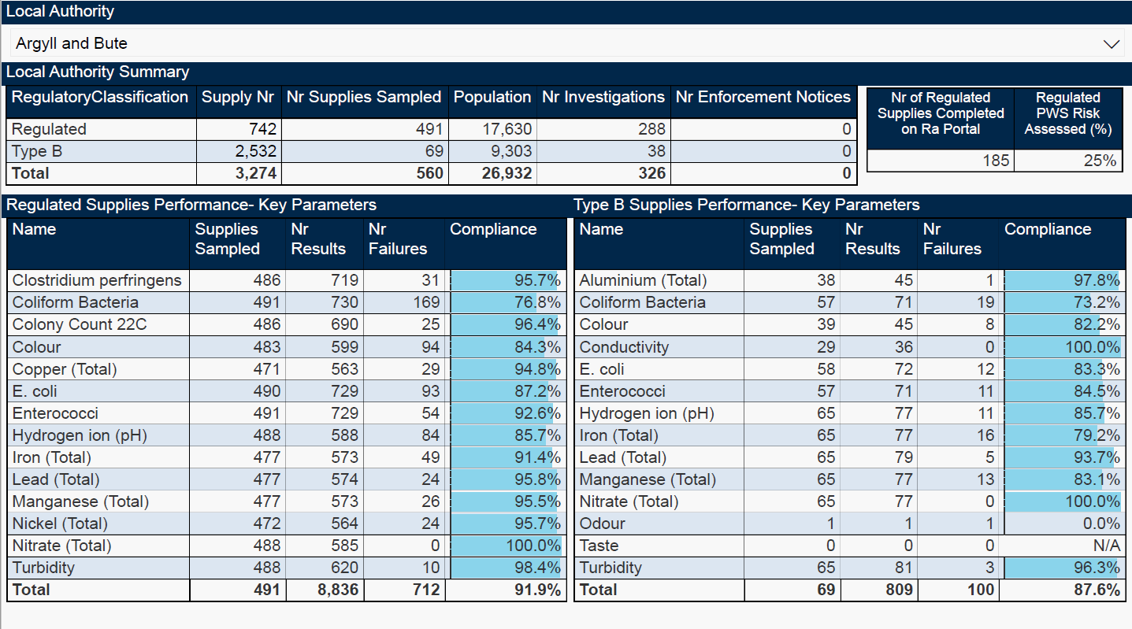

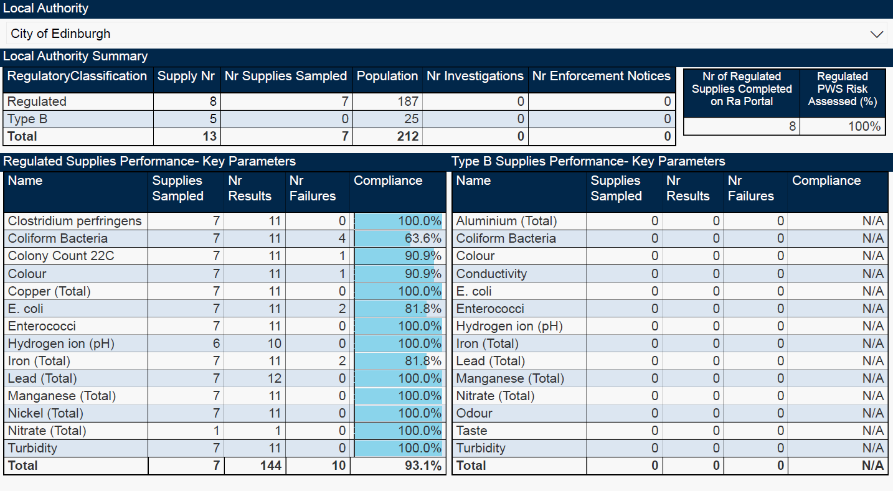

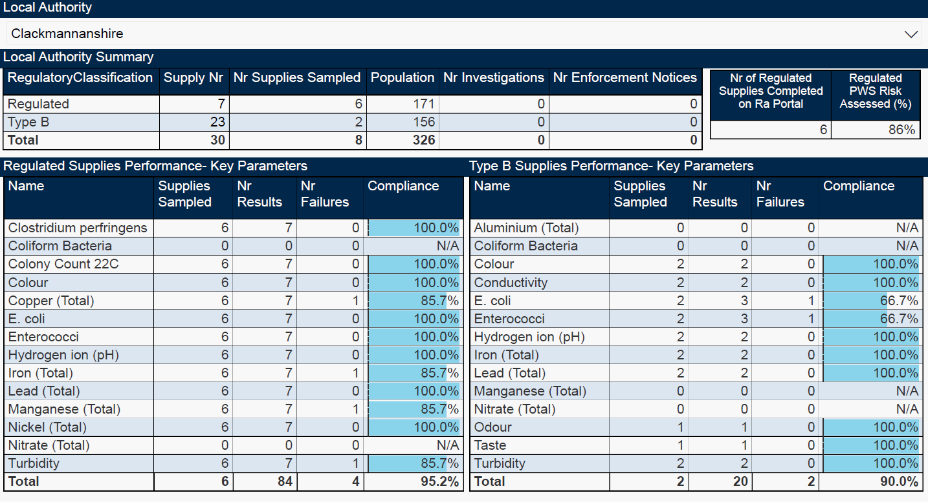

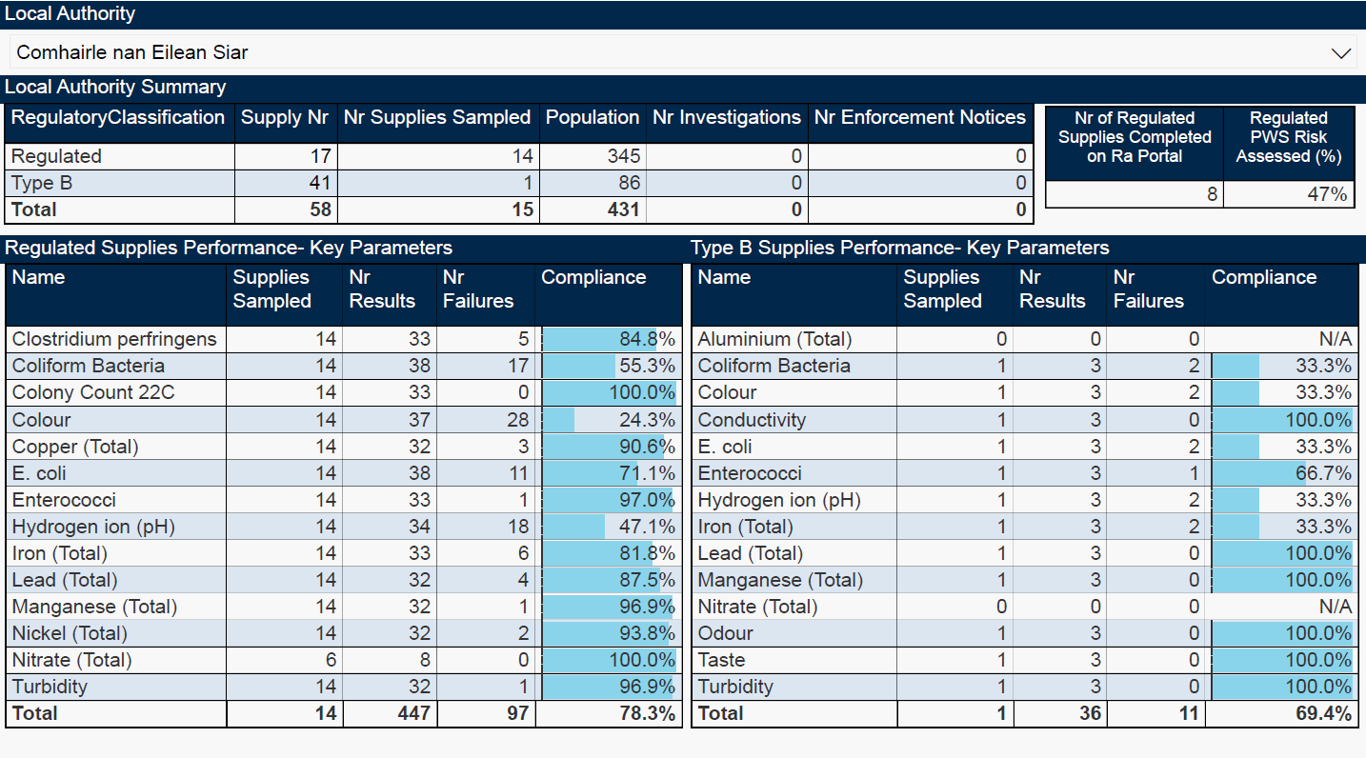

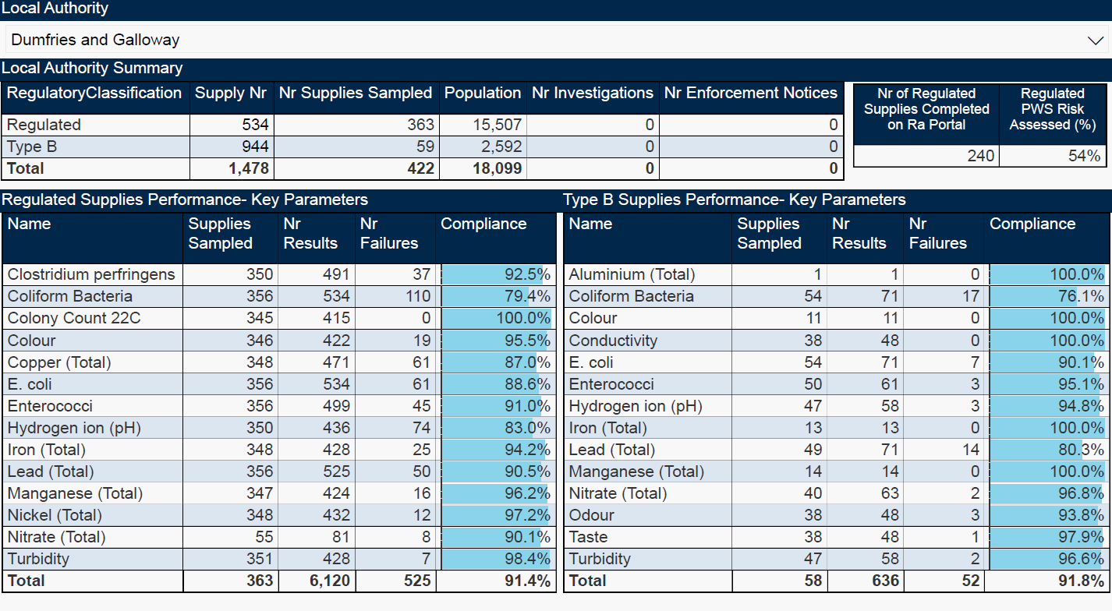

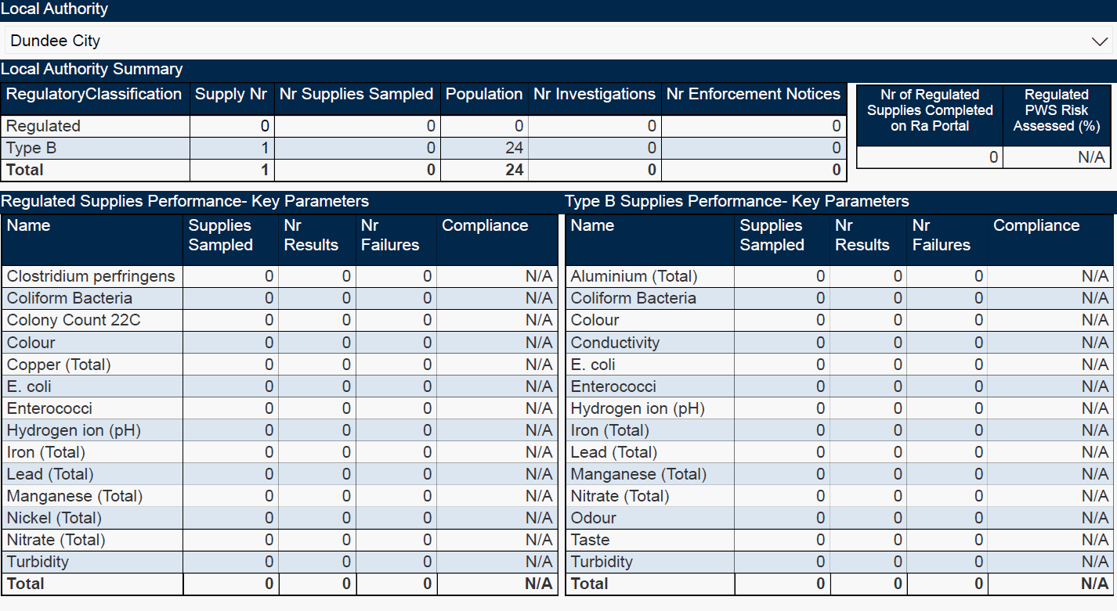

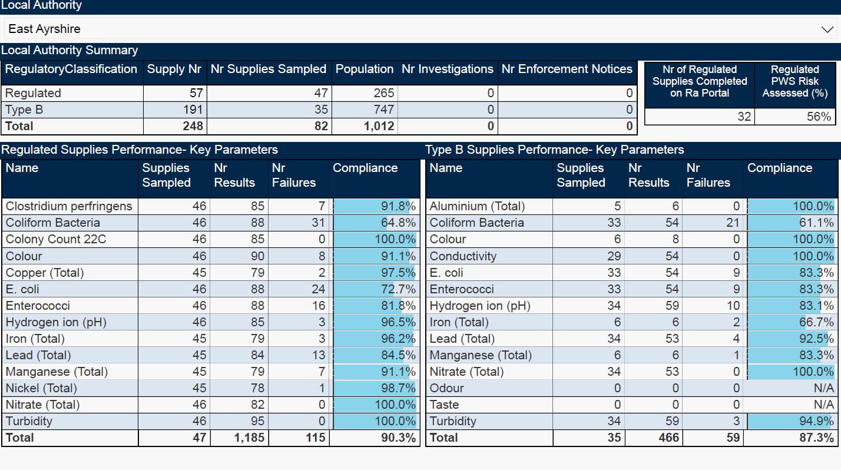

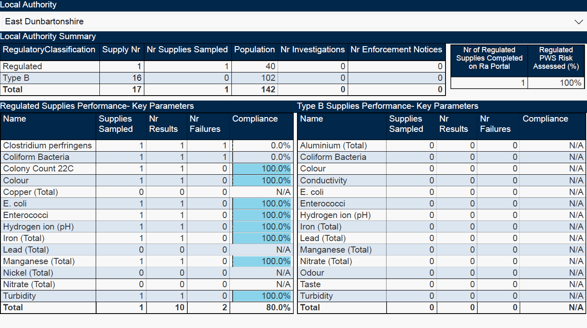

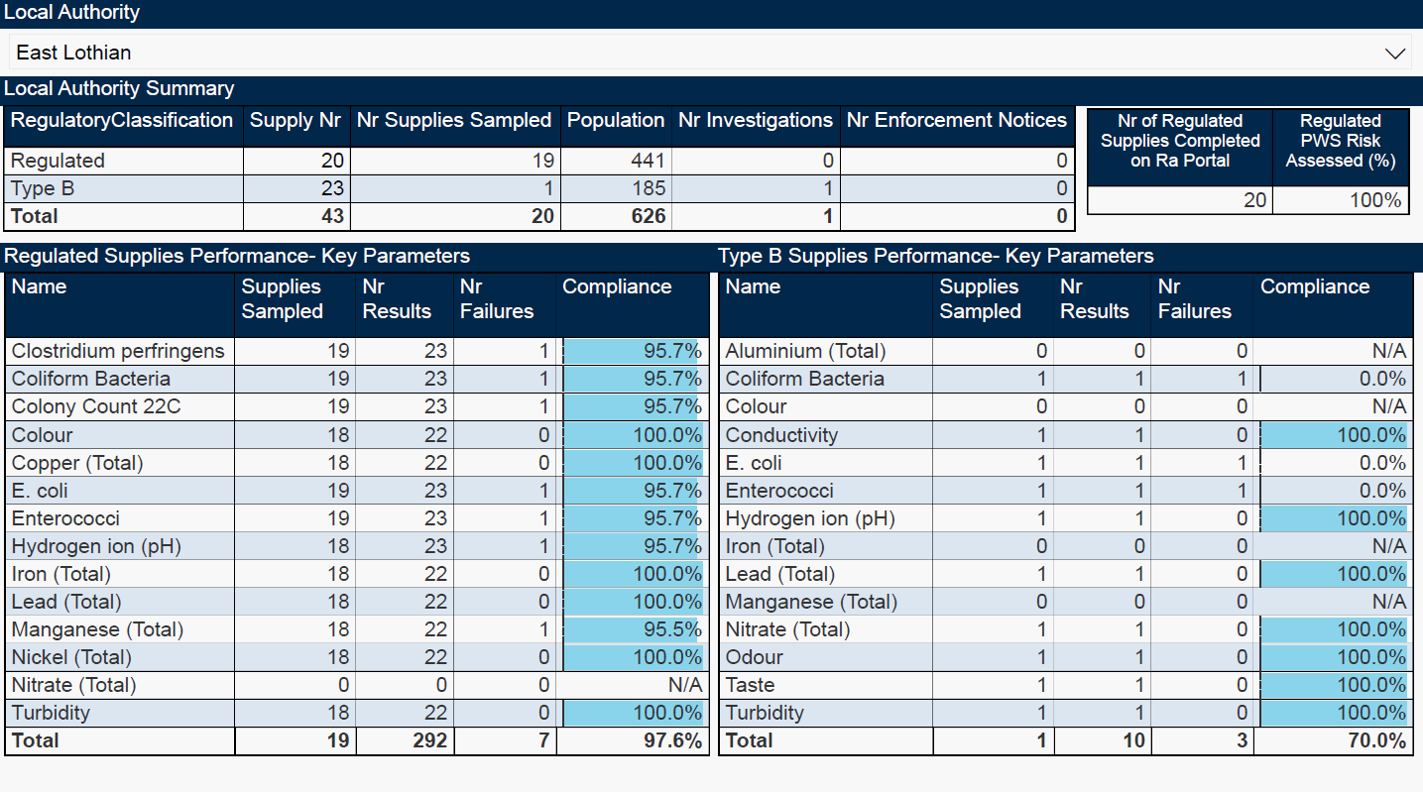

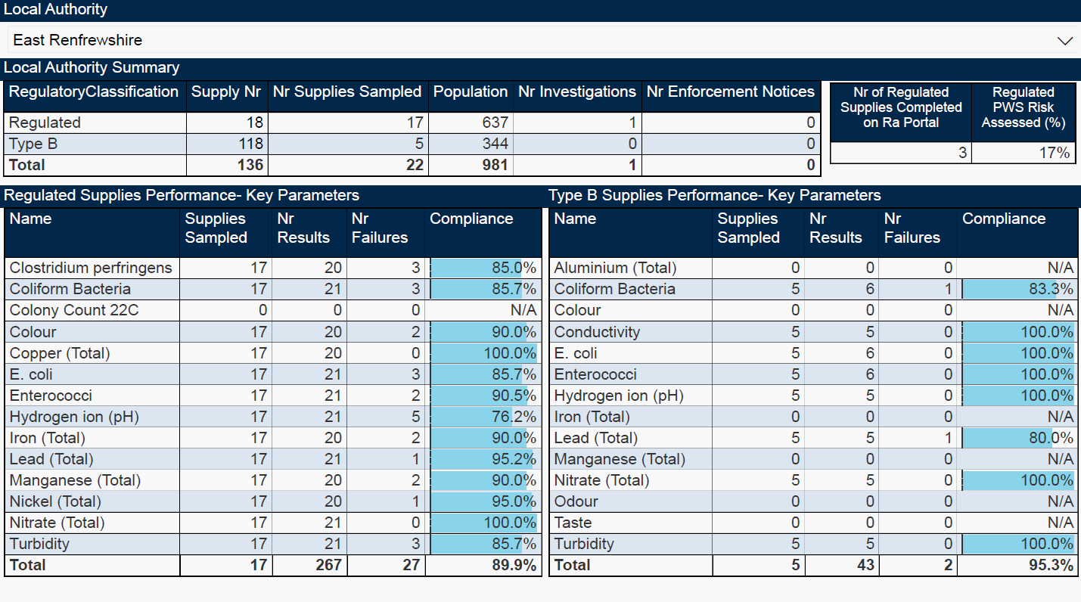

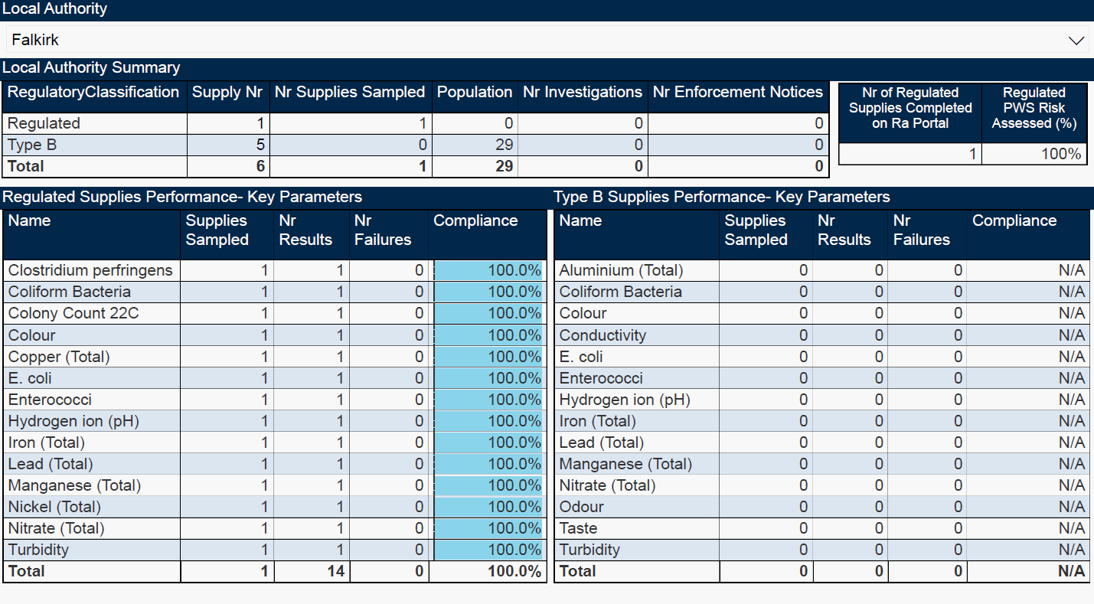

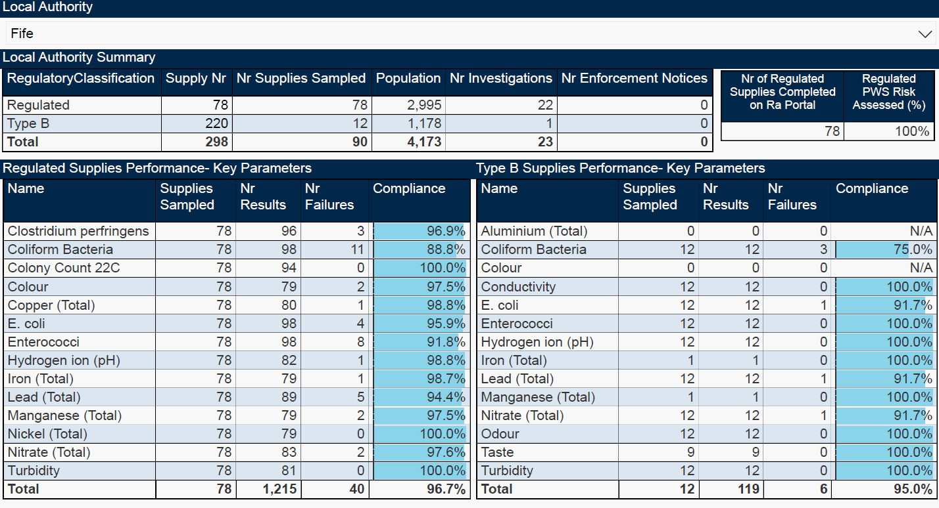

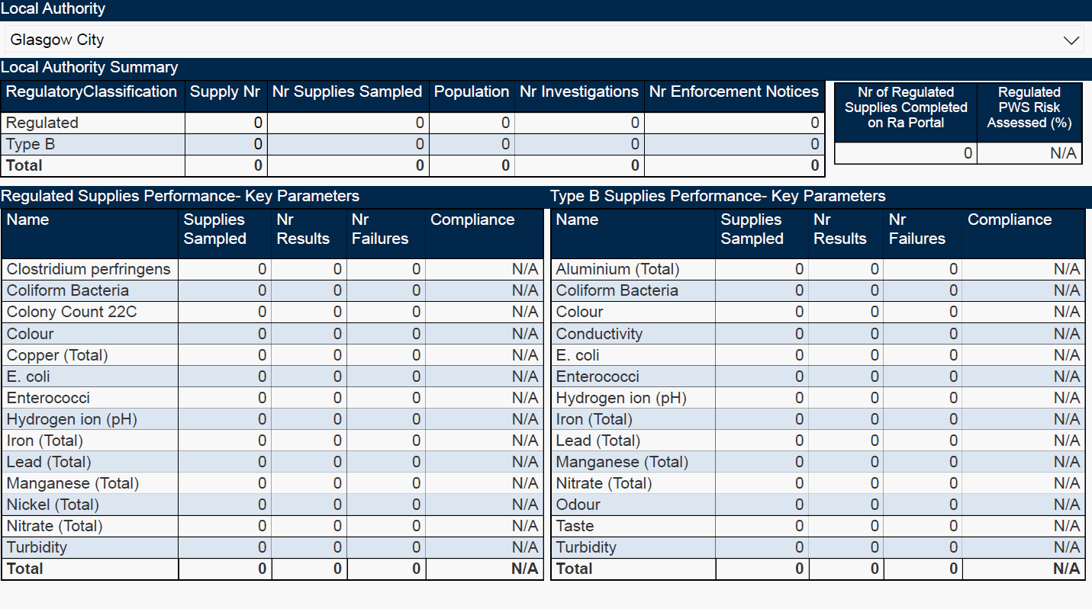

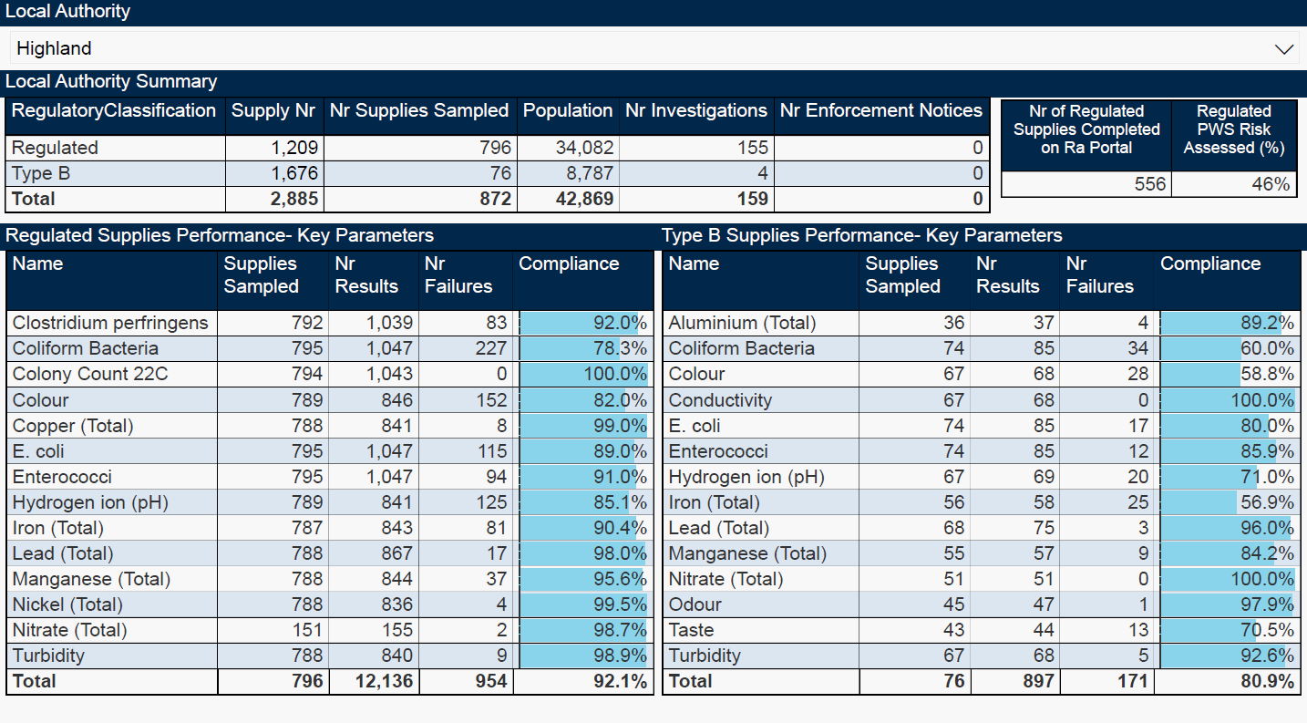

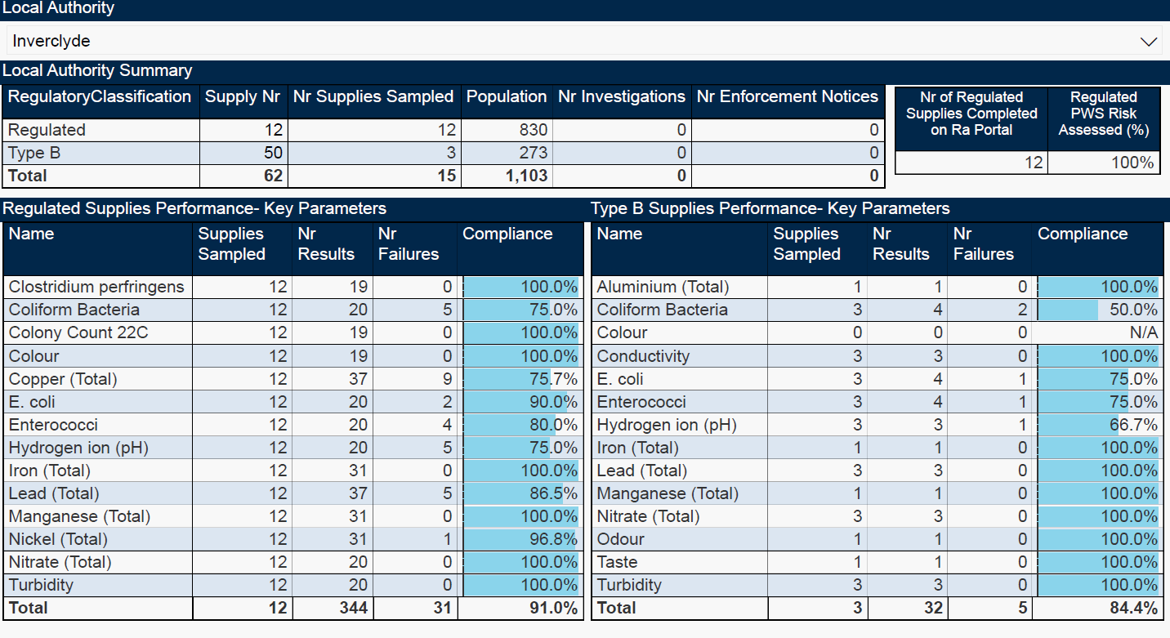

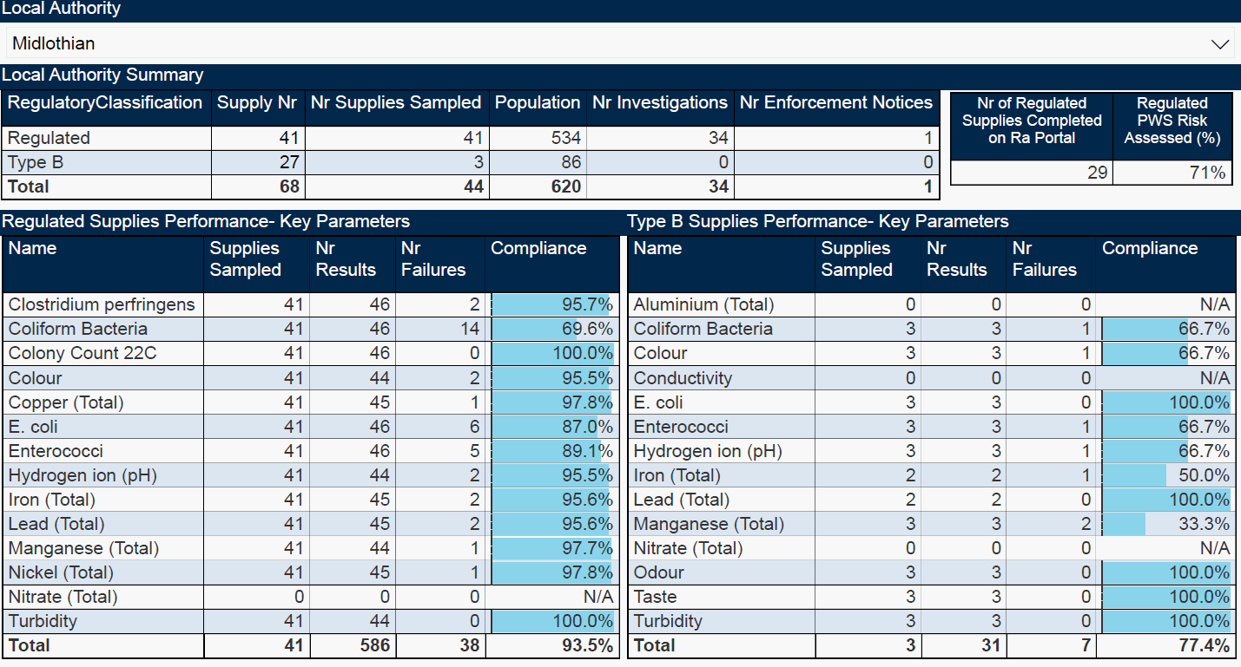

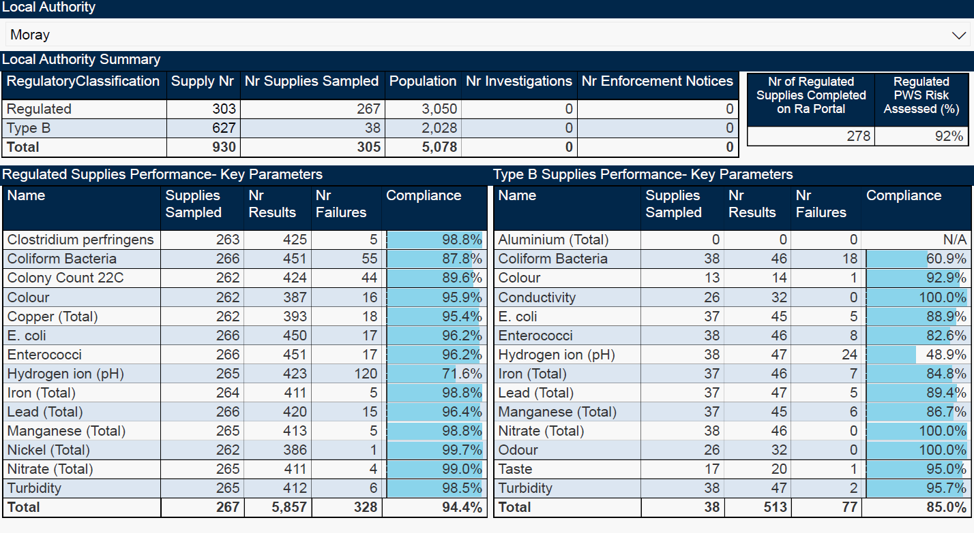

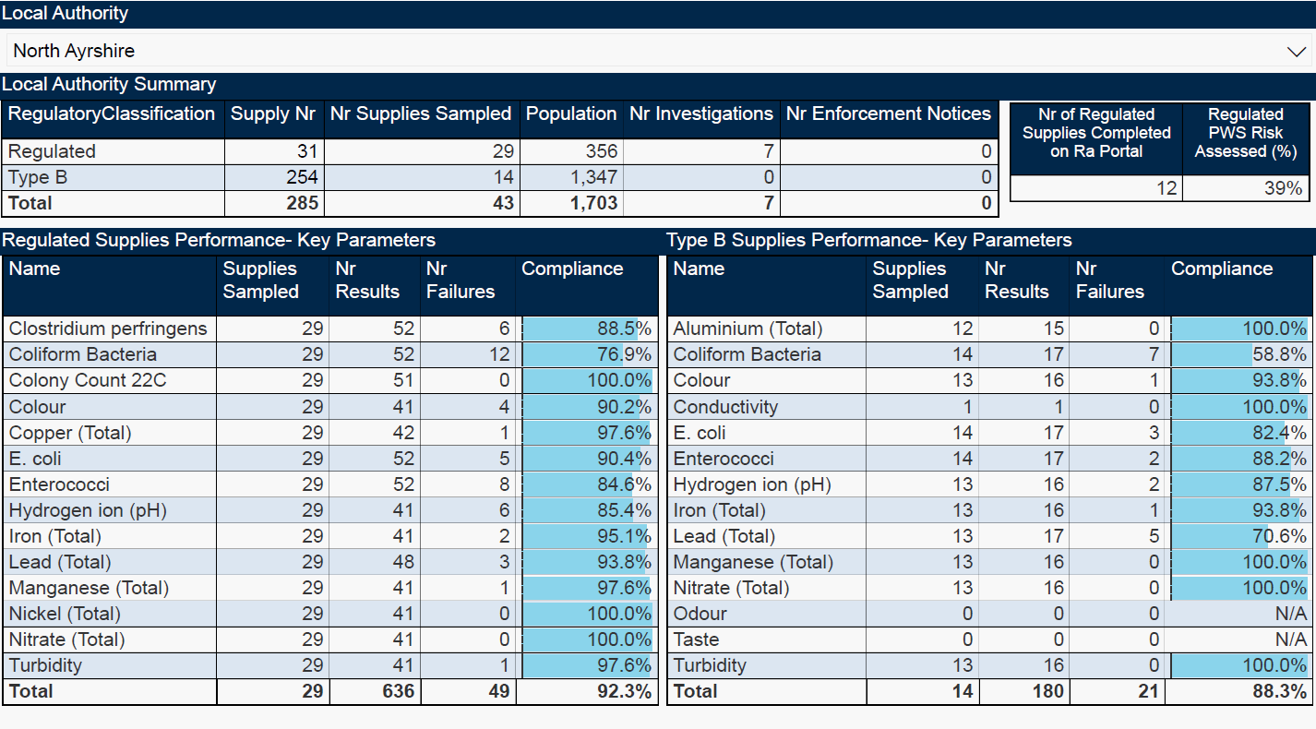

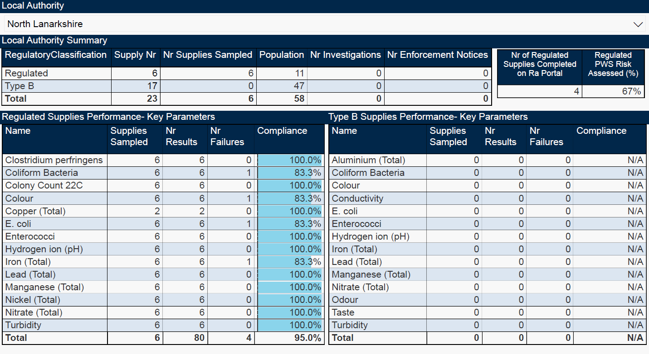

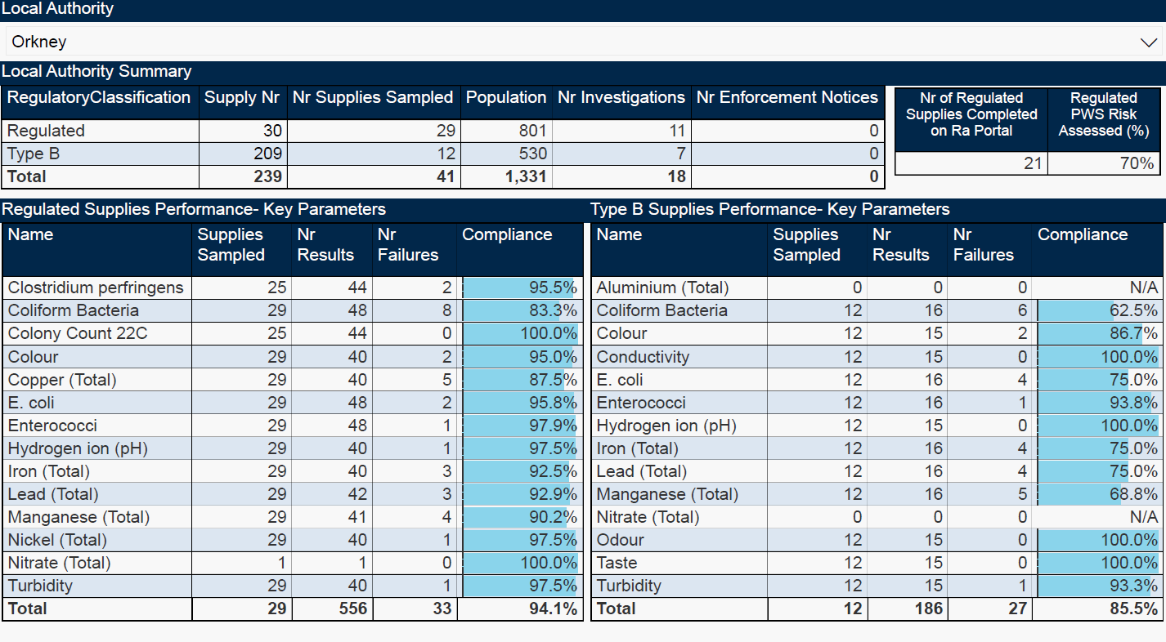

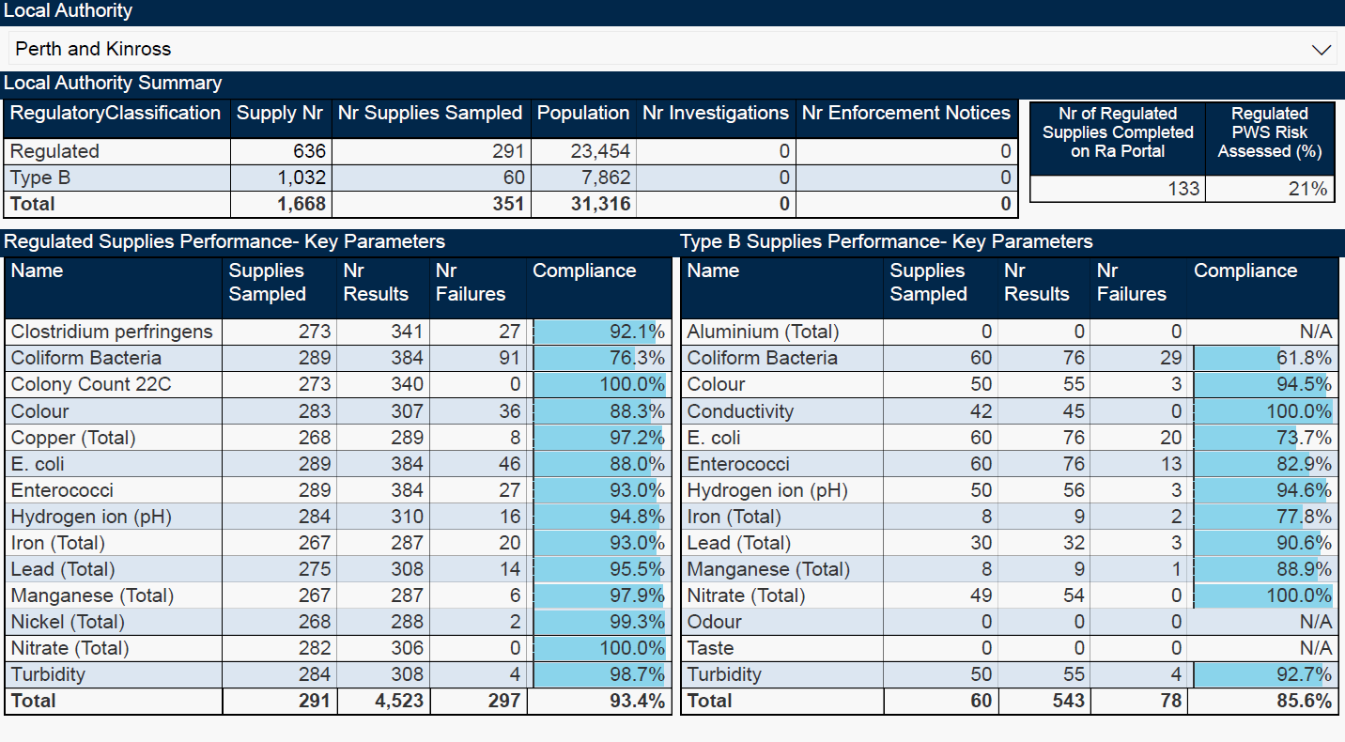

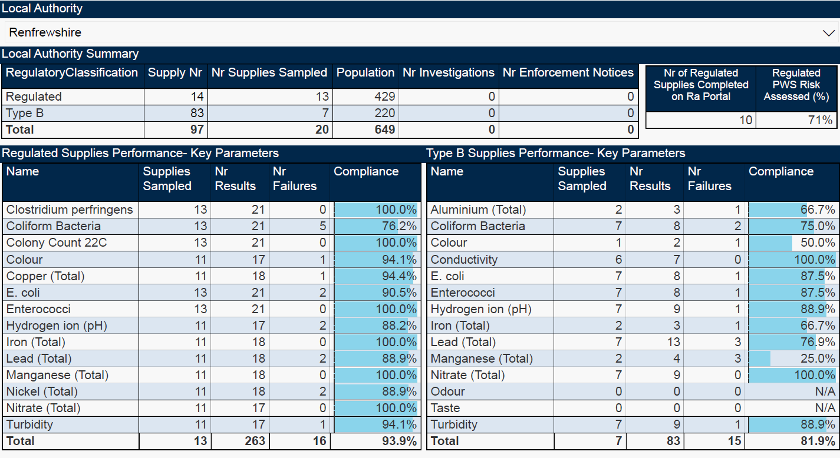

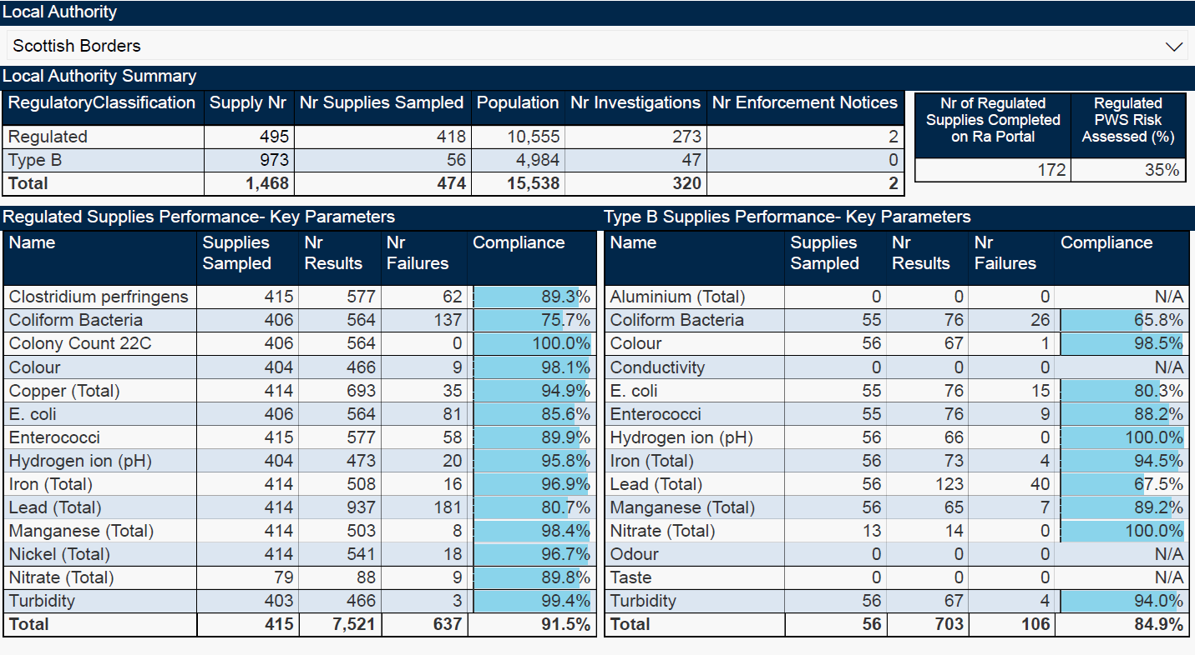

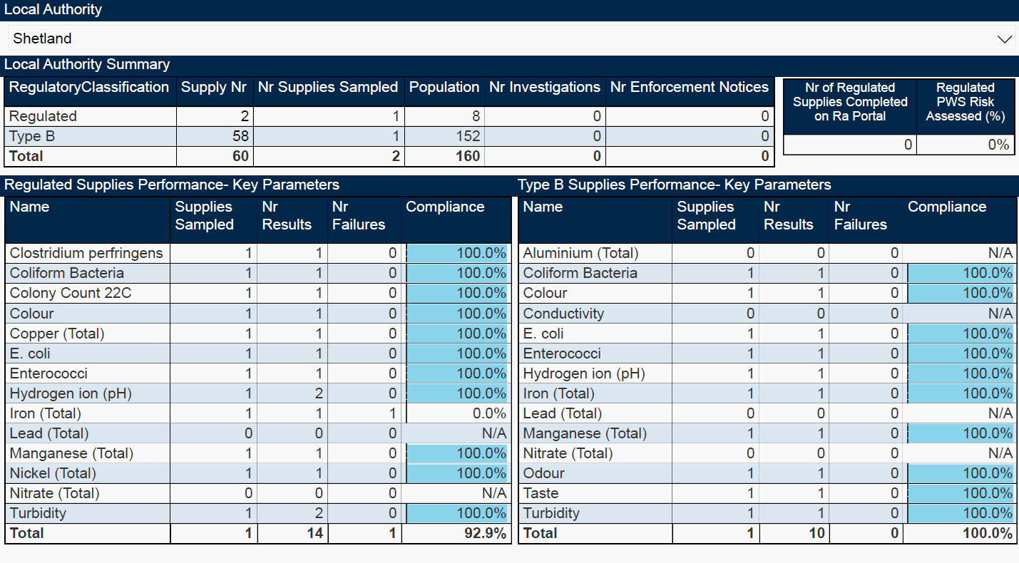

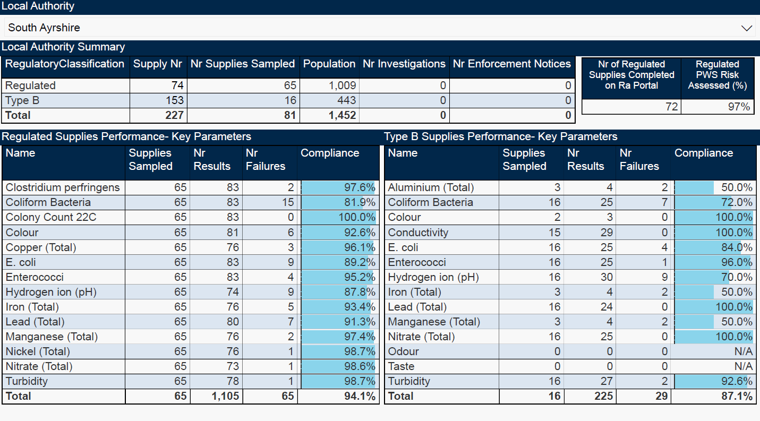

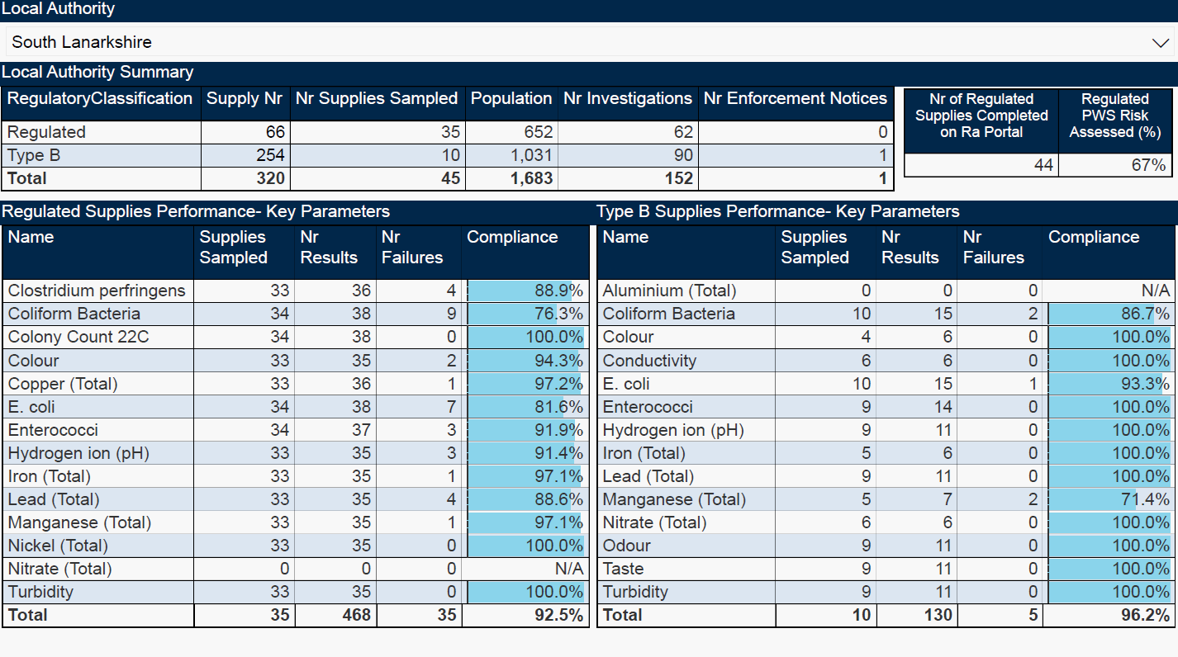

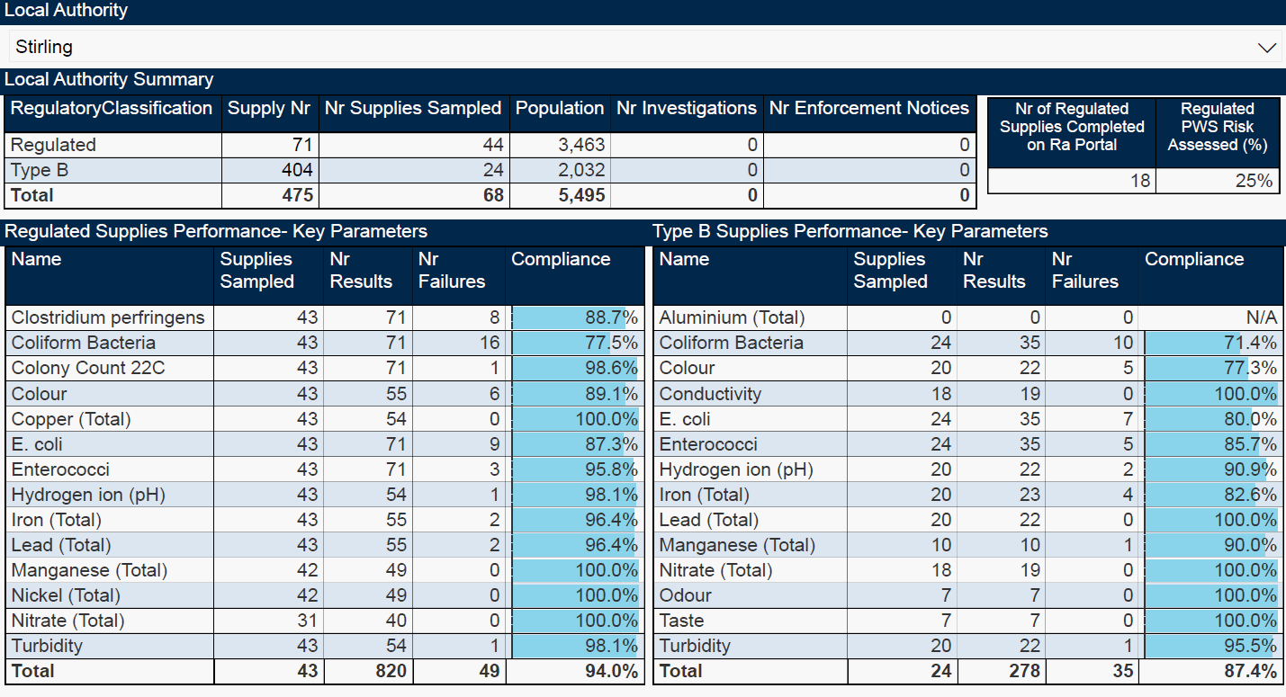

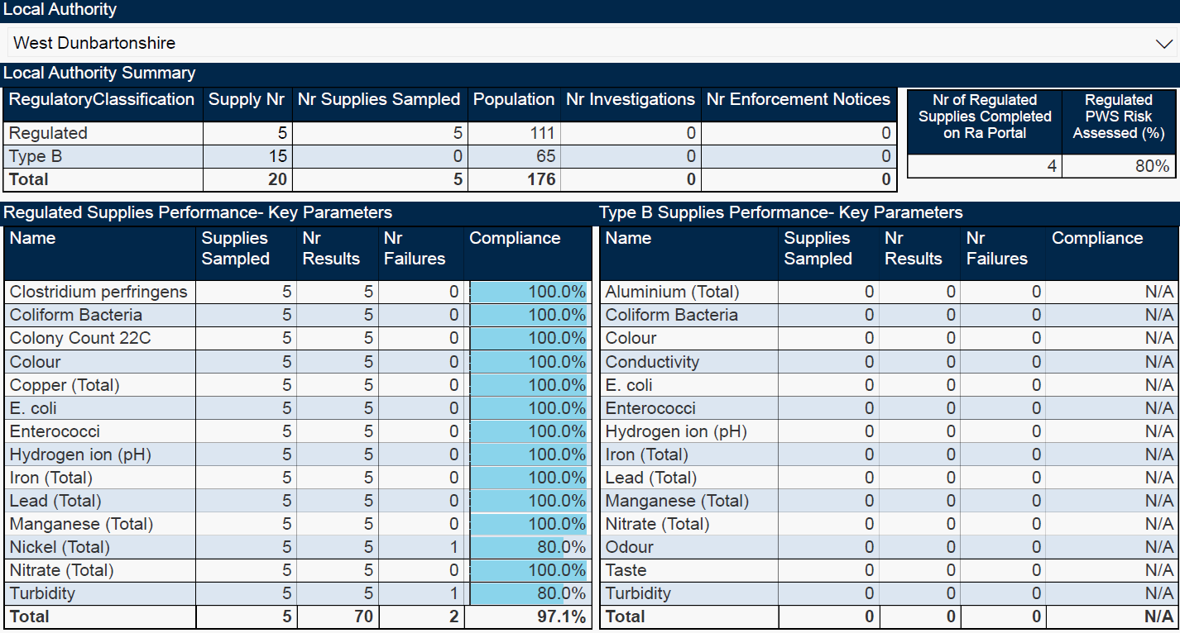

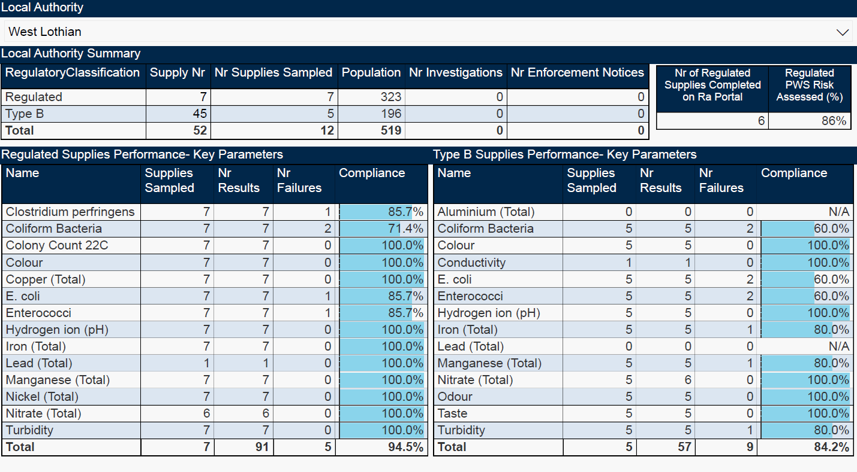

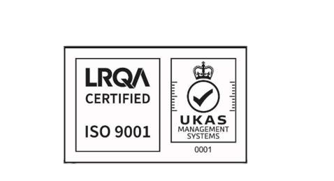

© Crown copyright 2025

Unauthorised reproduction in fringes. Crown copyright and may lead to prosecution or civil proceedings.

Published for the Drinking Water Quality Regulator for Scotland, September 2025.

