Lead in Drinking Water

Understanding Supply Pipes
Scottish Water provides the public water supply in Scotland and it has responsibility for the part of the service pipe and connection within the street - the Communication pipe. Where they encounter lead pipes within their ownership, they automatically replace those with modern materials.
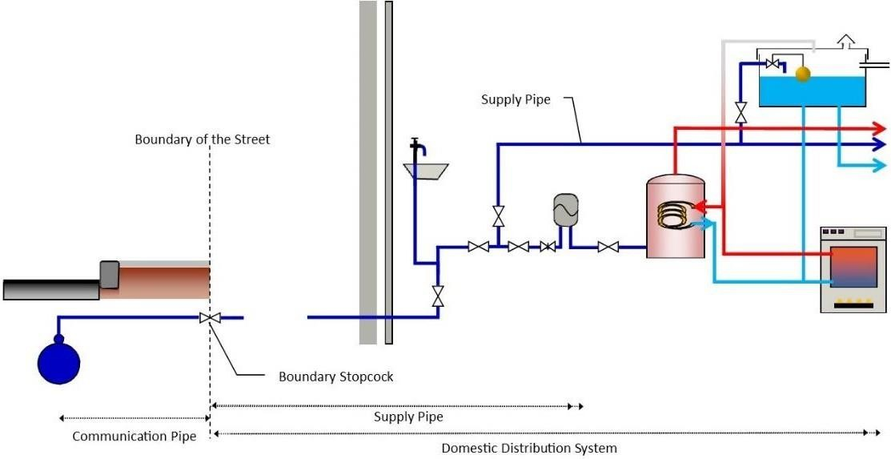
Diagram of Communication pipe and Supply pipes

Supply pipes and any pipes internal to the property - the domestic distribution system, are the responsibility of the property owners (or by the number of owners for the common elements of a shared supply). If you have reason to believe that lead is present in your supply you can contact Scottish Water and request that they take a sample of water from your property and inform you of the results.

If you have a private water supply, responsibilities for all, or parts of the water supply pipework will be subject to a local, specific agreement in property title deeds. If you are concerned you may have lead pipework then you can arrange to have a sample taken of your water by contacting the environmental health department at your local council.

If you are aware of, or discover any lead in your drinking water system, you are strongly advised to eliminate this to ensure that lead exposure is kept as low as possible, whether or not there is evidence of regulatory standards breach.

