Frequently Asked Questions on The Private Water Supply Risk Assessment Tool

I’m having trouble using the map- any hints?

The mapping function is currently quite basic, and we hope to develop it further in time.

  - Plotting Elements

As long as there is a valid grid reference for the element, it should plot on the map. By far the easiest way of getting a property registered and plotted is to use the postcode look up function. This will automatically populate the relevant information, including grid reference and UPRN so that the feature will plot on the map. All elements can be entered manually, but they will only plot if a valid grid reference has been entered.

If a grid reference is incorrect, it may try to plot the feature somewhere else. This could cause the whole map display to be of somewhere completely different. If the grid reference is completely invalid it may try to plot the points somewhere in the sea off Land’s End in Cornwall!

  - Zooming in and out
You can change the view of the map that you see by zooming in and out. Although there is (currently) no +/- button on the map, you can zoom in and out using the wheel on the mouse. Alternatively, keep clicking on a point on the map and it will zoom in around it.

  - Drawing Pipes
If you want to plot the line of a pipe between two elements, click on Add Pipe in the top left hand corner of the map.

You have two choices – to draw the pipe freehand, or to draw a series of straight lines. Either way, we recommend you zoom in as far as possible (with both elements visible) to make the plotting as accurate as possible.

  - Freehand Plotting
Click and hold the mouse on the point you want to start. Holding down the mouse button, trace the line of the pipe, double clicking the button when you reach the finish point to release. If you make a mistake and are unhappy with your pipeline, simply release the button and click on Add Pipe again and the line will be deleted.

  - Straight Line Plotting
You can draw an accurate straight line between two points by clicking on Add Pipe and then the start of point of your pipeline. Release the mouse button and double click on the end point, releasing again. A straight line will be drawn between the two points.

  - Deleting lines
You can delete the last line you drew by clicking on Add Pipe again. Alternatively, navigate away from the map, come back again and click on the line. A dialogue box will come up asking if you want to remove the pipe.

What exports am I supposed to be sending out to the owners / users?

We have deliberately left this flexible – it’s up to you decide what is appropriate for the audience and communicate in a way that they will understand and that is consistent with your local authority’s policy.

There are currently four types of reports. You can only produce these from RAs that have been submitted, not ones that are live. We will refine these and develop more as we get a better feel for how people want to use the tool:

Risk Assessment Data
This is a full excel report of all the information put into the RA, Including controls, validations and verifications. It’s probably more use for the local authority than for owners and users, but may be helpful if someone wants the complete risk assessment.

Risks and Mitigations
This is a linear summary table in excel of all risks and control measures. The format is basic but this is probably a more useful table to provide to owners and users.Simple Drinking Water Safety Plan
This is produces a simple excel table that shows basic statements on what needs to be done to look after the supply. It is designed for basic PWS and less experienced users.

The statements are tailored to the risks that are entered into the RA, for example if it is identified that source protection is a high risk, a comment of what might be done to protect the source will be shown in the table. If minimal risk is identified in that area, the comment won’t appear. The statements can be presented in their own right or
lifted from the table and inserted into a local authority’s own communication.

Full Drinking Water Safety Plan
This produces a fuller drinking water safety plan that can be adapted by the user to include the whole supply or parts of it, down to individual property level. It will produce a word document that includes all details of the risks above a threshold set by the user. These are broken down by location (e.g. source, tank etc), and list the control measures that are in place for each location as well as summarising the highest mitigated risk score.

There is then a space for actions required to reduce the risk at each location that is designed to be completed by the owner with the LA’s support. At the end of the document, there is a template table to list all those responsible for aspects of the supply (with some suggested roles) and a template emergency plan, again with suggested scenarios.

It is anticipated that this format will be more useful for larger commercial supplies who need some guidance on the sort of information they should be recording.

What exports am I supposed to be sending out to the owners / users?

We have deliberately left this flexible – it’s up to you decide what is appropriate for the audience and communicate in a way that they will understand and that is consistent with your local authority’s policy.

There are currently four types of reports. You can only produce these from RAs that have been submitted, not ones that are live. We will refine these and develop more as we get a better feel for how people want to use the tool. You can access these reports by clicking on a submitted version of a risk assessment (highlighted) on the site’s risk assessment page:
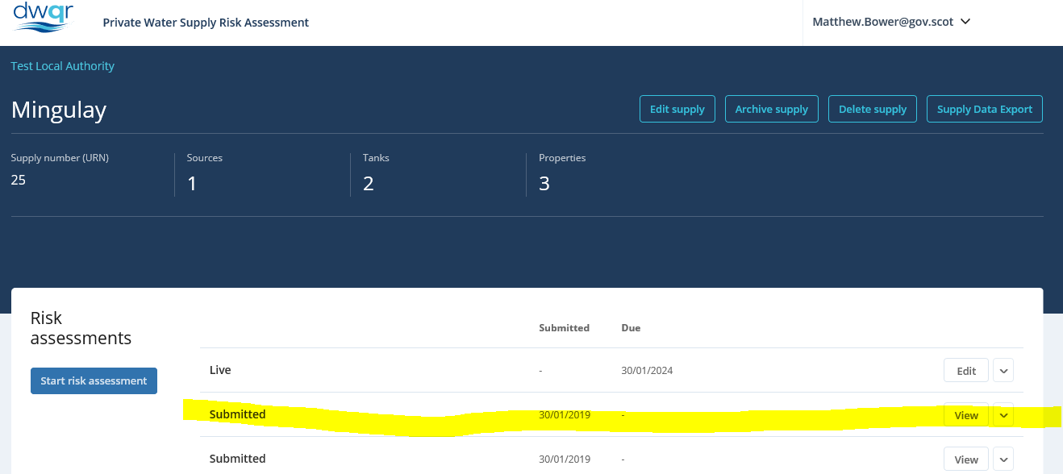

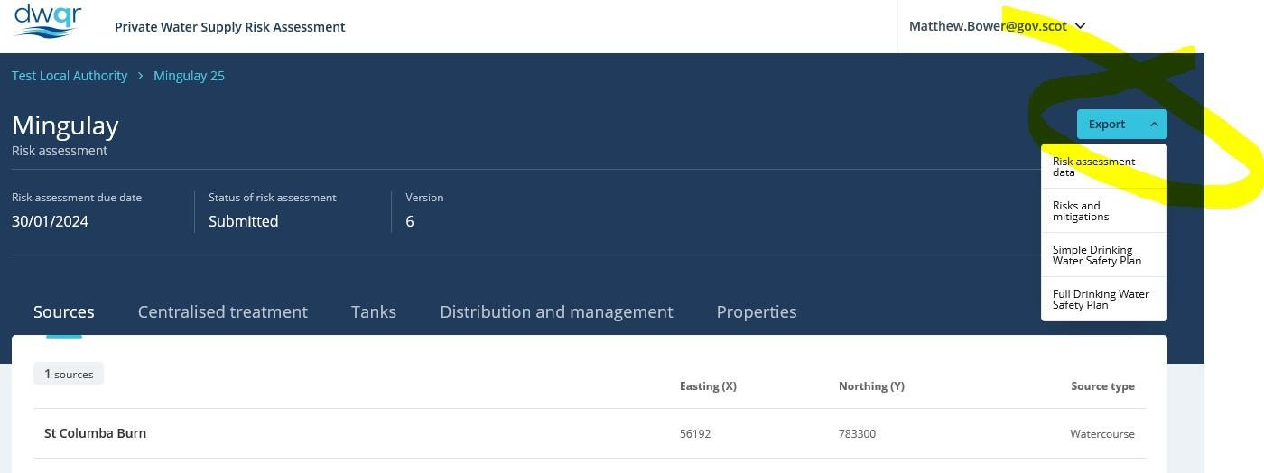You will see a blue “Export” button in the top right corner – clicking on this reveals four options:

Risk Assessment Data
This is a full excel report of all the information put into the RA, Including controls, validations and verifications. It’s probably more use for the local authority than for owners and users, but may be helpful if someone wants the complete risk assessment.

Risks and Mitigations
This is a linear summary table in excel of all risks and control measures. The format is basic but this is probably a more useful table to provide to owners and users.

Simple Drinking Water Safety Plan
This is produces a simple excel table that shows basic statements on what needs to be done to look after the supply. It is designed for basic PWS and less experienced users.

The statements are tailored to the risks that are entered into the RA, for example if it is identified that source protection is a high risk, a comment of what might be done to protect the source will be shown in the table. If minimal risk is identified in that area, the comment won’t appear. The statements can be presented in their own right or
lifted from the table and inserted into a local authority’s own communication.

Full Drinking Water Safety Plan
This produces a fuller drinking water safety plan that can be adapted by the user to include the whole supply or parts of it, down to individual property level. It will produce a word document that includes all details of the risks above a threshold set by the user. These are broken down by location (e.g. source, tank etc), and list the control measures that are in place for each location as well as summarising the highest mitigated risk score.

There is then a space for actions required to reduce the risk at each location that is designed to be completed by the owner with the LA’s support. At the end of the document, there is a template table to list all those responsible for aspects of the supply (with some suggested roles) and a template emergency plan, again with suggested scenarios.

It is anticipated that this format will be more useful for larger commercial supplies

who need some guidance on the sort of information they should be recording.

Why can’t I see the section that I need in the risk assessment?

The layout of the risk assessment is defined by the information that has been registered for the supply. If you are missing a section it may be that the register is incorrect.

To check, return to the front page for that supply (click on the name of the supply at the top of the page). You can quickly check the number of sources, tanks and properties that are registered in the dark blue area at the top of the page. If this is incorrect, click on Edit Supply and work through the sections to make sure that everything is correct.

You can only add elements of the supply in this section, so make sure everything is correct before you return to the risk assessment.

